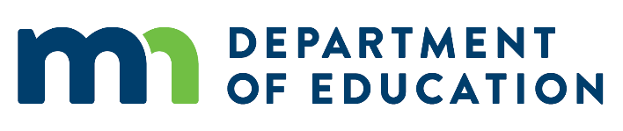
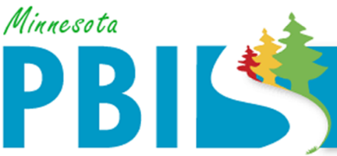

2017-2018 Minnesota PBIS District Recognition
In addition to individual school recognition, districts that are coordinating and supporting their PBIS schools are invited to apply for district recognition. To be identified for District PBIS Recognition, districts must demonstrate capacity for coordination, training, coaching and evaluation to support schools in their district to implement SW-PBIS.
There are two levels of recognition at the district level. The first is to highlight districts that are in progress towards sustaining implementation and have multiple schools measuring fidelity annually. The second is to highlight districts that have demonstrated exemplar district capacity with over 60% of schools implementing SW-PBIS with fidelity as measure annually.

There are four districts being recognized as 2017-2018 Exemplar District Capacity PBIS Districts:
Eastern Carver County Schools
Eastern Carver County Schools has 15 schools in the district. All 15 schools have been trained in PBIS. Fourteen schools have measured fidelity in the past year and all 14 are implementing SW-PBIS at Tier 1 with fidelity.

Forest Lake Area Schools
Forest Lake Area Schools has 13 schools in the district. All 13 schools have been trained in PBIS. Ten schools measured fidelity in the past year and 9 of the schools are implementing SW-PBIS at Tier 1 with fidelity.

Saint Cloud Area School District
St. Cloud Area School District has 16 schools in the district. All 16 have been trained in PBIS. Fifteen schools have measured fidelity in the past year and 9 of those are implementing SW-PBIS at Tier 1 with fidelity.

St. Paul Public Schools
St. Paul Public Schools has 63 schools in the district. Sixteen schools have been trained in PBIS through the state cohort model and an additional 14 have been trained internally. Twenty-nine schools measured fidelity in the past year and 28 of those are implementing SW-PBIS at Tier 1 with fidelity.

