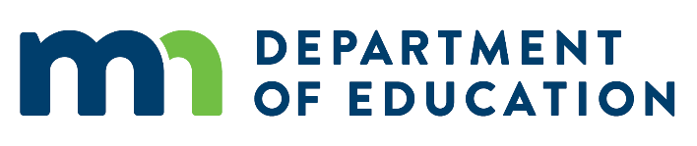
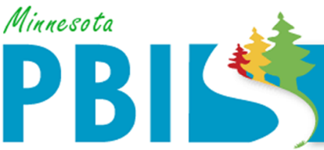

2019-2020 Minnesota PBIS District Recognition
In addition to individual school recognition, districts that are coordinating and supporting their PBIS schools are invited to apply for district recognition. To be identified for District PBIS Recognition, districts must demonstrate capacity for coordination, training, coaching and evaluation to support schools in their district to implement SW-PBIS.
There are two levels of recognition at the district level. The first is to highlight districts that are in progress towards sustaining implementation and have multiple schools measuring fidelity annually. The second is to highlight districts that have demonstrated exemplar district capacity with over 60% of schools implementing SW-PBIS with fidelity as measure annually.
Six (6) districts applied and met criteria. Each of the districts listed below demonstrated exemplar district capacity with over 60% of schools implementing SW-PBIS with fidelity.
- Burnsville-Eagan-Savage
- Cambridge-Isanti Schools
- Eastern Carver County Schools
- Osseo Area Schools
- Saint Paul Public Schools
- St. Cloud Area School District 742

