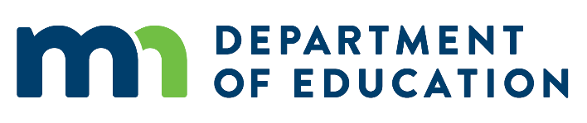
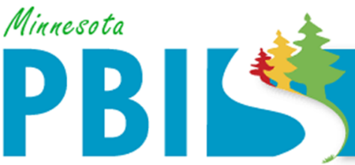

2020-2021 Minnesota PBIS District Recognition
In addition to individual school recognition, districts that are coordinating and supporting their PBIS schools are invited to apply for district recognition. To be identified for District PBIS Recognition, districts must demonstrate capacity for coordination, training, coaching and evaluation to support schools in their district to implement School-Wide Positive Behavioral Interventions and Supports (SW-PBIS).
There are two levels of recognition at the district level. The first is to highlight districts that are in progress towards sustaining implementation and have multiple schools measuring fidelity annually. The second is to highlight districts that have demonstrated exemplar district capacity with over 60% of schools implementing SW-PBIS with fidelity as measure annually.
Seven (7) districts applied and met criteria by either:
- Demonstrating exemplar district capacity with over 60% of schools implementing PBIS with fidelity annually; or
- Progressing toward sustaining implementation with multiple schools measuring fidelity annually.

- Bloomington Public Schools 271
- Burnsville-Eagan-Savage 191
- Cambridge-Isanti Schools 911
- Eastern Carver County 112
- Osseo Area Schools 279
- St. Cloud Area School District 742
- Waterville-Elysian-Morristown Public Schools 2143

