How to Open a TFI or SAS Window
Only people with Coordinator access can do this – contact us with questions
pbisMN.org/ContactUs.html

Video overview of PBIS Assessment 2
https://www.pbisapps.org/Resources/Pages/PBIS-Assessment-Overview-Webinar.aspx - start at 9:21

1. Login in to: pbisapps.org
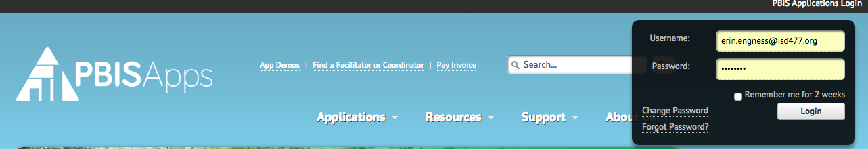

Can’t remember your username? Try your email
Can’t remember your password? Click “Forgot Password”
Not sure who the coordinator is for your team (or they have left your school)? Contact Erin Engness at pbis.erin@gmail.com

2. Click on PBIS Assessment (you won’t see all these choices listed on your account)

3. The screen should now be at your school’s account with your dashboard open.
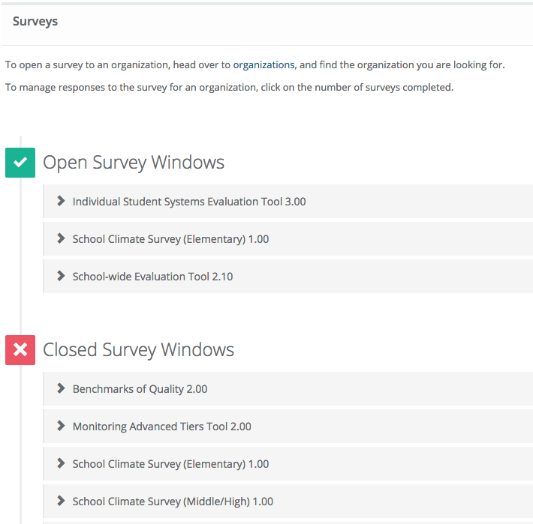
If you have access to multiple schools
then you need to go up to “my organizations”
in the toolbar and pick the school you
want to work with.

Open Survey Windows indicate what surveys
you currently have open. You can also access
data for those survey here.

Closed Survey Windows indicate what surveys
Have already been taken and are now closed.
You can access data for those surveys here.

4. To open a new survey click on “Surveys” at the top of the page. If your site is not already selected then do so.
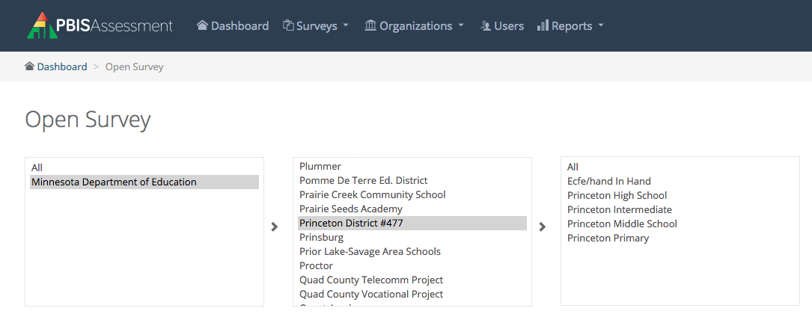

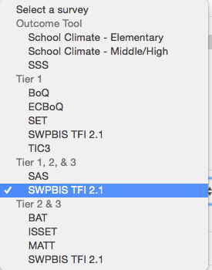
5. Choose your survey.

TFI = SWPBIS TFI 2.1
School Assessment Survey= SAS

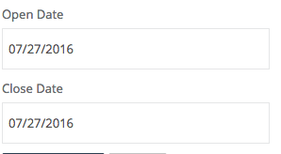
6. Choose and open and close date.

7. The survey should now appear in the “Open Surveys Window.”

Sometimes you do not see a list under the “Open Surveys Window” or “Closed Surveys Window.” Simply click the icon next to the heading and the list should appear.

8. To take the survey find it in the list and click “Take Survey.”
9. To see the reports attached to the data from the survey click “View Reports.”

