School Wide-Positive Behavioral Interventions and Supports (SWPBIS)

PBIS Team Training
Workbook

Center on Positive Behavioral Interventions and Supports
Minnesota Positive Behavioral Interventions and Supports
(updated July 2017)
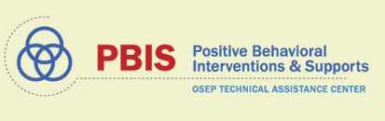  (www.pbis.org) | (www.pbisMN.org)
This document is supported in part by the OSEP Center on Positive Behavioral Interventions and Supports (http://pbis.org.) The Center is supported by a grant from the Office of Special Education Programs, US Department of Education (H326S130004). Opinions expressed herein are those of the authors and do not necessarily reflect the position of the US Department of Education, and such endorsements should not be inferred

Team Workbook

Take 2 minutes to determine roles within your groups for today’s training. The persons identified for these roles may be the same or different than the individuals filling these roles on your Tier 1 Team.

Team Roles | Name(s)
Coach/Facilitator  The Coach/Facilitator ensures that the group moves smoothly through the task at hand. This person seeks information and opinions, asks for facts and feelings from each team member, and summarizes main points of discussion. This role is very important because the facilitator leads the group through the tasks. | Coach/Facilitator
Recorder/Minute Taker  The recorder writes down the work of the group. This can involve writing words or sentences, drawing pictures, or simply taking notes of an activity. This role is very important because it is necessary to keep a record of the work done. | Recorder/Minute Taker
Time Keeper  This person is responsible for keeping up with the time. It is very important that the group is aware of how much time they have to complete the task as well as reminders on when the time is growing short. | Time Keeper
Reporter/Communicator  This person is responsible for reporting back the work of their small group to the presenter or to the larger group. This role is very important because this communication to the large group will be crucial in the learning process. | Reporter/Communicator
Data Analyst  This person should have ready access to available school data, including, but not limited to discipline information, etc. This role is important because data drives problem solving and decision-making. | Data Analyst

Appreciation is given to the following for their contributions to this Professional Learning
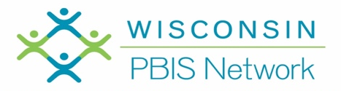
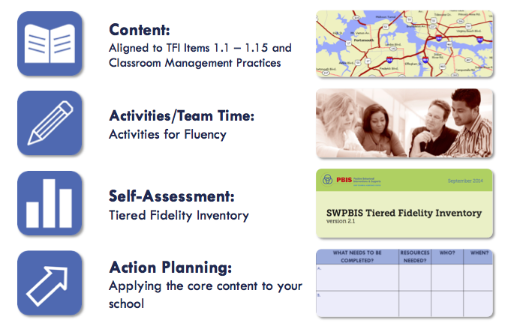

Organization of Modules

TIER I TRAINING: Overview 1A

Activity 1: How do you define and explain PBIS?

- Introduce yourself to your shoulder partner.
- First person explains PBIS in their words in 1 minute
- Second person reflect, and give feedback and/or additional details

Activity 2: My Personal Profile and Supports

- Use the blank triangle below to identify areas of your life where you are successful with Tier 1 supports, areas that need Tier 2 supports, and areas that need Tier 3 supports. Consider adding social, emotional, academic, physical, and/or professional examples.
My Profile

_______________________________________
_______________________________________

_______________________________________
_______________________________________
_______________________________________

_______________________________________
_______________________________________
_______________________________________
_______________________________________
_______________________________________
_______________________________________
_______________________________________

Corresponding Supports

_______________________________________
_______________________________________

_______________________________________
_______________________________________
_______________________________________

_______________________________________
_______________________________________
_______________________________________
_______________________________________
_______________________________________
_______________________________________
_______________________________________

- Next, identify an example of support for you receive for each area listed.

Activity 3: Rethinking Discipline
- Read the following information in the “Rethinking Discipline” chart. Record your thoughts.
- Share your thoughts with another person in your group.
- What did you hear from others that give you pause to rethink your understanding of discipline?
- Share the key ideas that may restructure your view of discipline with your team.

Rethinking Discipline

Academic & Social Problems: A Comparison of Approaches

Error Type | Approaches for Academic  Problems | Approaches for Social Problems
Infrequent | - Assume student is trying to make correct responses; error was accidental, a skill deficit.  - Provide assistance (teach, model, guide, check)  - Provide more practice and feedback; monitor progress.  - Assume student has learned skill and will perform correctly in the future. | - Assume student is choosing to be “bad;” error was deliberate, a performance deficit.  - Use consequences/punish.  - Practice not required.  - Assume student has “learned” lesson and will behave in the future.
Frequent | - Assume student has learned the wrong way or has inadvertently been taught the wrong way.  - Diagnose problem; identify misrule or determine more effective way to teach.  - Adjust teaching arrangements to accommodate learner needs. Provide practice and feedback.  - Assume student has learned skill and will perform correctly in the future. | - Assume the student is refusing to cooperate; student knows what is right, has been told to stop, and is being insubordinate.  - Provide more severe consequences; remove the student from normal context (office referral, detention, suspension, etc.)  - Maintain student removal from the normal context.  - Assume student has “learned” lesson and will behave in the future.

Activity 4: Creating a Vision (use chart paper and post-its if possible)
Guiding Question:
Do you have a vision that compels new ways of thinking and acting?
Working with your staff or team, discuss your vision of your school:
- Use post-it notes capture your ideas. Add your ideas to the chart paper.
- If you could create the school of your dreams, what would it LOOK like and SOUND like with a positive, proactive, and instructional approach to discipline?
- What are your intended OUTCOMES for your school?
- How will this align with your School Improvement Plan, your Mission & Vision Statements?
- Is this vision consistent with your 3-5 Positively Stated School-Wide Expectations?

Thinking about our Team Vision/Purpose
As a result of our efforts, our school will…
Look like …  What will we see? | Sound like …  What will we hear?
Achieve these outcomes …

TIER I TRAINING: TEAMS 1B
Team Composition and Team Operating Procedures

Activity 1: Initiative Inventory
Quick Audit/Resource Map of Current Practices within Three-Tiered Model of Support

Use a large sheet of chart paper to draw a large triangle and complete the following activity.
Step 1: Identify all programs/initiatives/common practices by tier
Tier I - How do you support all children? Core Curriculum - “everyone gets”
Tier II, III - How do you support students who need more support? How do you build on the foundation so that all Tier II, III activities are a natural extension of core curriculum?

Tier I
List Core practices provided to all students and intended to support most students

Tier III
List Individualized/Intensive practices provided to a few students for support

Tier II
List Strategic/Targeted practices provided to some students for support

Step 2: Consider the following questions:
Can you identify an outcome for each practice? Are these evidence-based practices?
How do you measure effectiveness? (Staff performance)
How do monitor progress? (Student impact)
How do you support teachers? (Staff supports)
How are they linked to School Improvement? (Integrated approach)

Directions: Identify any additional action steps needed. Do you need to enlist the other members of your team, and faculty to complete this quick audit of practices at your school?

Activity 2: Aligning Teaming Structures =Initiative Inventory
(Working Smarter, Not Harder)

Use the Initiative Inventory worksheet to complete the next two steps:
Step 1: Identify Current Teams (discipline, instruction, climate, school improvement, parent support, etc.) and Initiatives (Second Step, Character Counts, Spirit Committee, etc.)
Step 2: Complete the Working Smarter Table
Step 3: Based on your results, what committees or initiatives can you eliminate; combine; provide more support? How can you infuse PBIS into your current committees/teams?

Initiative/  Committee/ Team | Purpose and Strategic Goal Supported | Measurable Outcome(s) – Data Based | Target Group | Staff Involved | Overlap? Modify?  Eliminate?

Activity 3: Behavior Purpose Statement

Develop a brief statement of purpose relative to the development and support of the social and behavioral climate of the school. When developing the statement consider the following guidelines:
- Positively Stated
- 2-3 sentences in length
- Supportive of academic achievement
- Contextually/culturally appropriate (e.g., age, level, language)
- Comprehensive in scope (school-wide, ALL students, staff and settings)
- Agreement by >80% faculty and staff
- Communicated to stakeholders (e.g., families, community members, district administrators)
- Included in school publications (e.g., handbook, posters, newsletters)
- Reviewed at every team meeting

Activity 4: Effective Meetings: Team Composition
Identify your team members.
Step 1: Complete the following chart to ensure that your team includes a Tier I school-based coach, a school administrator, a family member, and individuals able to provide: behavioral expertise, coaching expertise, knowledge of student academic and behavioral patterns, knowledge about the operations of the school across grade levels; and student representation.

Step 2: Identify who will be the Data Entry person, the Data Analyst, the Facilitator, and Minute Taker for the TIPS process. Identify back-ups for each role.

Step 3: Identify the administrator and additional active team members.

Step 4: Determine dates to meet (at least monthly) and dates to present to the faculty (share data at least quarterly).

Name | Role | Back-Up | Email | Phone #
Day to meet: |  |  | Time:
Location: Dates to present to faculty:

Activity 5: Effective Meetings: Agenda and structure during team meetings

Step 1:Review the TIPS Meeting Agenda format in the appendix.
Step 2: Identify and discuss key sections of the agenda
  - Member Names
  - Agenda Items
  - Previous Precision Problem Statement
  - General Issues
  - New Precision Problem Statement
  - Evaluation of Meeting

Step 3: Plan for the format/content of your team meeting.

Activity 5: Working Agreements = Norms
Reflect on the professional behaviors that characterize efficient and effective meetings you have attended. What working agreements will support your team’s work and heighten your productivity?

TIER I TRAINING: TEAMS
Team Composition and Team Operating Procedures

Tiered Fidelity Inventory: Tier I
Features
1.1 Team Composition:
Tier I team includes a Tier I systems coordinator, a school administrator, a family member, and individuals able to provide (a) applied behavioral expertise, (b) coaching expertise, (c) knowledge of student academic and behavior patterns, (d) knowledge about the operations of the school across grade levels and programs, and for high schools, (e) student representation.
1.2 Team Operating Procedures:
Tier I team meets at least monthly and has (a) regular meeting format/agenda, (b) minutes, (c) defined meeting roles, and (d) a current action plan
TFI | Action Item  (Not In Place; Partially; Fully In Place ->) | NI | PI | FI
1.1 | Team has administrative support and represents school community
1.1 | Back-up members are identified for all team functions (coach, data-analyst, recorder, data-entry, etc.)
1.2 | Team has established a clear mission/purpose and current action plan.
1.2 | Team runs efficient and effective regular meetings (at least monthly) with agenda and meeting minutes
1.2 | School administrator is an active participant in 90% of meetings, protects meeting time, disseminates information during grade level/department meetings, faculty meetings, and parent/family meetings.
1.2 | Working Smarter Teaming Alignment document is completed

TIER I TRAINING: IMPLEMENTATION: Behavioral Expectations 1C

Activity 1: Build Expectations
If your school system does not have school-wide expectations, proceed to developing expectations for your school, consider the following activity:
- Each team member gets three sticky notes to record one expectation per sticky note.
- Enter expectations considered in the box below.
- Reach consensus as a team on three to five
- Can you give your school expectations an easy to remember and catchy name?

Expectations Considered | Ideas for the Name of School Expectations

Activity 2: Creating a Matrix
Enter your agreed upon expectations on the matrix below

Expectations Name: _____________________ | Expectations | Locations
 | Conditions for Learning/Teacher Supports

Activity 3: Locations
Guiding Question: What does your map look like?
- Draw a diagram/map of your school in this box, on chart paper, or use a copy of your school map.
- Each person identifies 3 top problem locations
- On the bottom half, identify where, what, who, when, and why.

Map of our school

Where? | What? | When? | Who? | Why are they happening?

Activity 4: Teaching Matrix
Using the information from Activity 3, identify the locations of your school and enter them onto the matrix above.

Activity 5: Behaviors
Using the information from “where”, “what”, “when”, “who” and “why”, begin to identify possible rules for the locations in your school. What problems were identified? What do you want to see instead?

When defining specific behaviors/rules they should be:
- Observable behaviors – that we can see
- Measureable – we could actually count the occurrence of the behavior
- Positively stated – what to do to be successful
- Understandable – student-friendly language
- Always applicable – able to accomplish in all settings in the school

Activity 6: Finalizing your School-wide Matrix
- Consider adding supports for teachers (i.e. conditions for learning)
- Consider adding pro-social skills
- Prepare to share one completed location with the group (e.g., what does Respect look like in the cafeteria?)

Activity 7: Classroom Rules
Define classroom rules aligning with School-wide expectations. Complete one square and prepare to share.

Setting ➔ | Classroom Rules | Classroom Routines
School-wide Expectation ⬇

Activity 8: Classroom Procedures and Routines
Identify at least one routine in the classroom. Define the steps and align the steps to the school-wide expectations. Add the routine to the Classroom Matrix in Activity 7. Prepare to share.

TIER I TRAINING: IMPLEMENTATION
Behavioral Expectations

Tiered Fidelity Inventory: Tier I Features
1.3 Behavioral Expectations:
School has five or fewer positively stated behavioral expectations and examples by setting/location for student and staff behaviors (e.g., school teaching matrix) defined and in place.

TFI | Action Item  (Not In Place; Partially; Fully In Place ->) | NI | PI | FI
1.3 | Staff are involved in development of expectations and rules
1.3 | 3-5 positively stated school-wide expectations are posted around school
1.3 | Teaching matrix is developed to identify rules linked to expectations in various areas in the school
1.3 | Rules are posted in specific settings/locations
1.3 | Expectations apply to both students and staff
1.8 | Classroom rules are defined, aligned to school-wide expectations, and are posted in classrooms.
1.8 | Classroom routines and procedures are explicitly identified for activities where problems often occur (e.g. entering class, asking questions, sharpening pencil, using restroom, dismissal)

TIER I TRAINING: IMPLEMENTATION - Teaching Expectations 2A
Activity 1: Develop Lesson Plans
- Choose a rule/routine from the school-wide or classroom-wide matrix.
- Work with your shoulder partner or team to complete the behavior lesson plan template at your table.
- Be ready to describe your lesson to the group and possibly role-play the example and non-example.

Expectation:
Location:
Establish/Define Behavior/Procedure:
Introduce the behavior and why it is important. Be sure to list when the behavior is expected:
1.

2.

3.
TEACH

Teacher demonstrates or models the behavior. Discuss non-examples and examples.
1.

2.

3.
PRACTICE

Give students opportunities to role-play the behaviors across all relevant settings.
1.

2.

3.
MONITOR AND REINFORCE
- Pre-Correct/Remind: Anticipate and give students a reminder to perform behaviors
- Supervise: Move, scan and interact with students.
- Feedback: Observe student performance and give positive, specific feedback to students.
- Reteach: Practice throughout the day and school year.
Activity 2: Creating a Plan for Teaching Desired Behaviors
Once the behavior lesson plans are created it is important to take time to decide how the lessons will be taught, not only at the beginning of the year, but throughout the year.
- Create a draft plan to teach expectations. Encourage input from all staff members to complete the Teaching Expectations Plan.

What will be done? | How will it be done? | When will it be done?
Use “best instructional practices” to teach social skills?

Introduce the expectations

Will you embed into subject area curriculum?
Create/Post the Matrix

Establish a signal for obtaining class attention & transitions

Model what the expectations look like
Will faculty and staff model appropriate behavior?
Practice with students
Will you teach directly in settings? (i.e. bus expectations taught on bus)
Provide specific feedback

Acknowledge students who demonstrate the expected behavior
Pre-correct and Review often

How will lessons be taught throughout the school year?
How will lessons be taught to new students and new faculty/staff?

TIER I TRAINING: IMPLEMENTATION
Teaching Expectations

Tiered Fidelity Inventory: Tier I Features
1.4 Teaching Expectations: Expected academic and social behaviors are taught directly to all students in classrooms and across other campus settings/locations.

TFI | Action Item  (Not In Place; Partially; Fully In Place ->) | NI | PI | FI
1.4 | A behavioral curriculum includes teaching expectations and rules for each location in the school
1.4 | Lesson include examples and non-examples (student/staff practice examples only)
1.4 | Lessons use a variety of teaching strategies
1.4 | Lessons are embedded into subject area curriculum
1.4 | Lessons will be taught and re-taught throughout the school year
1.4 | Staff and students are involved in development & delivery of behavioral curriculum
1.4 | Strategies to share key features of PBIS program with families/community are developed and implemented
1.4 | Identify dates on the school’s professional development calendar when the expectations will be formally taught to all students
1.7 | Identify dates on the school’s professional development calendar when the plans for teaching expectations will be shared with staff
1.8 | Expected classroom behaviors and routines are taught

TIER I TRAINING: EVALUATION 2B
Fidelity Data and Annual Evaluation

Activity 1: Fidelity Data and Annual Evaluation
Guiding Questions:
- What are the different types of data your team will be using to make decisions about PBIS implementation?
- What kind of “statement” do you need to be able to make regarding your data? What are the pieces of that statement?
- What is your elevator speech for when colleagues ask you about “all this data collection”?

TIER I TRAINING: EVALUATION
Fidelity Data and Annual Evaluation
Activity 1: Rationale
Guiding Questions:
- What is your elevator speech for why decisions should be data based in the school discipline context?

Activity 2: Is Our Data System Effective and Efficient?
Directions
- With your Tier 1 team, answer the following questions.
- Problem-solve

Question | Yes/No? | Action Plan
Are we collecting the right information? What, where, when, who, why)
Is data collection efficient?
  - Less than 60 sec to fill out,
less than 30 sec to enter
Do we get data in the right format?
  - Graphic format
Do we get the data at the right time?
  - Before and during meetings
  - Data no more than 24 hours old
Does our Data-Analyst prepare in advance, and bring a draft Precision Problem Statement to our team meetings to present?
Are data used for decision-making by all?
  - Data presented to all faculty at least monthly
  - Data available for whole school, small group and individual student evaluation
  - Data collected on FIDELITY (what we do) as well as IMPACT (student behavior)

Activity 3: Solution Development and Action Planning
Directions
- Use the following precision statement to create each of the solution components to address that problem. Be prepared to share.
There are 25% more ODRs for aggression on the playground this month than last year. These are most likely to occur during first recess, with a large number of students, and the aggression is related to getting access to the new playground equipment.

Solution Component | Action Step(s)
Prevention
Teaching
Recognition
Extinction
Corrective Consequence
Data Collection

Activity 4: Practice Problem Solving
Directions
- Complete the following components of the problem-solving process.
- Use your own school data; or use a sample scenario provided during training (e.g. cafeteria hallway).

1. | Precision Problem Statement:
2. | Set Measurable Goal:
3. | Proposed Solution and Action Plan: | Prevention:  Teaching:  Recognition:  Extinction:  Corrective  Consequence:  Data Collection:
4. | Fidelity Monitoring Plan:
5. | What outcome data do you see as a result?  Did you achieve the goal, or do you need to revise a component  of your problem-solving process?

Tiered Fidelity Inventory: Tier I Features
1.14 Fidelity Data:
Tier I team reviews and uses PBIS fidelity (e.g., SET, BoQ, SAS, Tiered Fidelity
Inventory) data at least annually.
1.15 Annual Evaluation:
Tier I team documents fidelity and effectiveness (including on academic outcomes) of Tier I practices at least annually (including year-by-year comparisons) that are shared with stakeholders (staff, families, community, district) in a usable format.

TFI | Action Item  (Not In Place; Partially; Fully In Place ->) | NI | PI | FI
1.14 | Students and staff are surveyed
1.14 | Students and staff can identify expectations and rules
1.14 | Staff use referral process (including which behaviors are office managed vs. teacher managed) and forms appropriately
1.14 | Staff use acknowledgment system appropriately
1.14 | Outcomes (behavior problems, attendance, morale) are documented and used to evaluate plan
1.14 | Staff, student and family surveys are developed with timeline for completion
1.14 | Intended student outcomes are identified and monitored
1.15 | Fidelity tools are identified, administered and used to inform action planning

Tiered Fidelity Inventory (TFI)
Tiered Fidelity Inventory – Tier 1
Tier 1 Subscale and Feature | Definition |  | Possible Data Sources | Criteria  0=Not implemented; 1=Partially implemented; 2=Fully implemented |  | Score 0, 1, 2
TEAMS
1.1 Team Composition | Tier I team includes a Tier I systems coordinator, a school administrator, a family member, and individuals able to provide (a) applied behavioral expertise, (b) coaching expertise, (c) knowledge of student academic and behavior patterns, (d) knowledge about the operations of the school across grade levels and programs, and for high schools, (e) student representation. |  | - School organizational chart  - Tier I team meeting minutes | 0 = Tier I team does not exist or does not include coordinator, school administrator, or individuals with applied behavioral expertise  1 = Tier I team exists, but does not include all identified roles or attendance of these members is below 80%  2 = Tier I team exists with coordinator, administrator, and all identified roles represented, AND attendance
1.2 Team Operating Procedures | Tier I team meets at least monthly and has (a) regular meeting format/agenda,  (b) minutes, (c) defined meeting roles, and (d) a current action plan. |  | - Tier I team meeting agendas and minutes  - Tier I meeting roles descriptions  - Tier I action plan | 0 = Tier I team does not use regular meeting format/ agenda, minutes, defined roles, or a current action plan  1= Tier I team has at least 2 but not all 4 features  2 = Tier I team meets at least monthly and uses regular meeting format/agenda, minutes, defined roles, AND has a current action plan
IMPLEMENTATION
1.3 Behavioral Expectations | School has five or fewer positively stated behavioral expectations and examples by setting/location for student and staff behaviors (i.e., school teaching matrix) defined and in place. |  | - TFI Walkthrough Tool  - Staff handbook  - Student handbook | 0 = Behavioral expectations have not been identified, are not all positive, or are more than 5 in number  1 = Behavioral expectations identified but may not include a matrix or be posted  2 = Five or fewer behavioral expectations exist that are positive, posted, and identified for specific settings (i.e., matrix) AND at least 90% of staff can list at least 67% of the expectations
1.4 Teaching Expectations | Expected academic and social behaviors are taught directly to all students in classrooms and across other campus settings/locations. |  | - TFI Walkthrough Tool  - Professional development calendar  - Lesson plans  - Informal walkthroughs | 0 = Expected behaviors are not taught  1 = Expected behaviors are taught informally or inconsistently  2 = Formal system with written schedules is used to teach expected behaviors directly to students across classroom and campus settings AND at least 70% of students can list at least 67% of the expectations
1.5 Problem Behavior Definitions | School has clear definitions for behaviors that interfere with academic and social success and a clear policy/ procedure (e.g., flowchart) for addressing office-managed versus staff-managed problems. |  | - Staff handbook  - Student handbook  - School policy  - Discipline flowchart | 0 = No clear definitions exist, and procedures to manage problems are not clearly documented  1 = Definitions and procedures exist but are not clear and/or not organized by staff- versus office-managed problems  2 = Definitions and procedures for managing problems are clearly defined, documented, trained, and share with families
1.6 Discipline Policies | School policies and procedures describe and emphasize proactive, instructive, and/ or restorative approaches to student behavior that are implemented consistently. |  | - Discipline policy  - Student handbook  - Code of conduct  - Informal administrator interview | 0 = Documents contain only reactive and punitive consequences  1 = Documentation includes and emphasizes proactive approaches  2 = Documentation includes and emphasizes proactive approaches AND administrator reports consistent use
1.7 Professional Development | A written process is used for orienting all faculty/staff on 4 core Tier I SWPBIS practices: (a) teaching school-wide expectations, (b) acknowledging appropriate behavior, (c) correcting errors, and (d) requesting assistance. |  | - Professional development calendar  - Staff handbook | 0 = No process for teaching staff is in place  1 = Process is informal/unwritten, not part of professional development calendar, and/or does not include all staff or all 4 core Tier I practices  2 = Formal process for teaching all staff all aspects of Tier I system, including all 4 core Tier I practices
1.8 Classroom Procedures | Tier I features (school-wide expectations, routines, acknowledgements, in-class continuum of consequences) are implemented within classrooms and consistent with school-wide systems. |  | - Staff handbook  - Informal walkthroughs  - Progress monitoring  - Individual classroom data | 0 = Classrooms are not implementing Tier I  1 = Classrooms are informally implementing Tier I but no formal system exists  2 = Classrooms are formally implementing all core Tier I features, consistent with school-wide expectations
1.9 Feedback and Acknowledge-ment | A formal system (i.e., written set of procedures for specific behavior feedback that is [a] linked to school-wide expectations and [b] used across settings and within classrooms) is in place and used by at least 90% of a sample of staff and received by at least 50% of a sample of students. |  | - TFI Walkthrough Tool  - Staff Handbook | 0 = No formal system for acknowledging students  1 = Formal system is in place and is used by at least 90% of staff OR received by at least 50% of students  2 = Formal system for acknowledging student behavior is used by at least 90% of staff AND received by at least 50% of students
1.10 Faculty Involvement | Faculty are shown school- wide data regularly and provide input on universal foundations (e.g., expectations, acknowledgements, definitions, consequences) at least every 12 months. |  | - PBIS Self-Assessment Survey  - Informal surveys  - Staff meeting minutes  - Team meeting minutes | 0 = Faculty are not shown data at least yearly and do not provide input  1 = Faculty have been shown data more than yearly OR have provided feedback on Tier I foundations within the past  12 months but not both  2 = Faculty are shown data at least 4 times per year AND have provided feedback on Tier I practices within the past 12 months
1.11 Student/ Family/ Community Involvement | Stakeholders (students, families, and community members) provide input on universal foundations (e.g., expectations, consequences, acknowledgements) at  least every 12 months. |  | - Surveys  - Voting results from parent/ family meeting  - Team meeting minutes | 0 = No documentation (or no opportunities) for stakeholder feedback on Tier I foundations  1 = Documentation of input on Tier I foundations, but not within the past 12 months or input but not from all types of stakeholders  2 = Documentation exists that students, families, and community members have provided feedback on Tier I practices within the past 12 months
EVALUATION
1.12 Discipline Data | Tier I team has instantaneous access to graphed reports summarizing discipline data organized by the frequency of problem behavior events by behavior, location, time of day, and by individual student. |  | - School policy  - Team meeting minutes  - Student outcome data | 0 = No centralized data system with ongoing decision making exists  1 = Data system exists but does not allow instantaneous access to full set of graphed reports  2 = Discipline data system exists that allows instantaneous access to graphs of frequency of problem behavior events by behavior, location, time of day, and student
1.13 Data-based Decision Making | Tier I team reviews and uses discipline data and academic outcome data (e.g., Curriculum-Based Measures, state tests) at least monthly for decision-making. |  | - Data decision rules  - Staff professional development calendar  - Staff handbook  - Team meeting minutes | 0 = No process/protocol exists, or data are reviewed but not used  1 = Data reviewed and used for decision-making, but less than monthly  2 = Team reviews discipline data and uses data for decision-making at least monthly. If data indicate an academic or behavior problem, an action plan is developed to enhance or modify Tier I supports
1.14 Fidelity Data | Tier I team reviews and uses SWPBIS fidelity (e.g., SET, BoQ, TIC, SAS, Tiered Fidelity Inventory) data at least annually. |  | - School policy  - Staff handbook  - School newsletters  - School website | 0 = No Tier I SWPBIS fidelity data collected  1 = Tier I fidelity collected informally and/or less often than annually  2 = Tier I fidelity data collected and used for decision making annually
1.15 Annual Evaluation | Tier I team documents fidelity and effectiveness (including on academic outcomes) of Tier I practices at least annually (including year- by-year comparisons) that are shared with stakeholders (staff, families, community, district) in a usable format. |  | - Staff, student, and family surveys  - Tier I handbook  - Fidelity tools  - School policy  - Student outcomes  - District reports  - School newsletters | 0 = No evaluation takes place, or evaluation occurs without data  1 = Evaluation conducted, but not annually, or outcomes are not used to shape the Tier I process and/ or not shared with stakeholders  2 = Evaluation conducted at least annually, and outcomes (including academics) shared with stakeholders, with clear alterations in process based on evaluation
Total Score | Items/Points | Points Award/Points Possible |  |  | Percentage of PBIS Implementation
Tier 1 | 1-15 / 30 points | ____________ / 30

PBIS Action Plan:

Directions:
- Complete the following action plan to document steps toward implementation of PBIS.
- See Action Items at the end of each module in the workbook to identify action steps for inclusion in plan.
- Add additional action steps as identified by team.

Subscale and  Tier 1 Features | Score from TFI:  0, 1, 2 | Action Steps: |  | Who? |  | When?
TEAMS
- Team Composition  DAY 1 |  | 1.  PD Plan:
- Team Operating Procedures  DAY 1 |  | 1.  PD Plan:
IMPLEMENTATION
- Behavioral Expectations  DAY 2 |  | 1.  PD Plan:
1.4 Teaching Expectations |  | 1.  PD Plan:
1.5 Problem Behavior Definitions |  | 1.  PD Plan:
1.6 Discipline Policies |  | 1.  PD Plan:
1.7 Professional Development |  | 1.
1.8 Classroom Procedures  DAY 2 and DAY 5 |  | 1.  PD Plan:
1.9 Feedback and Acknowledgement |  | 1.  PD Plan:
1.10 Faculty Involvement |  | 1.  PD Plan:
1.11 Student/Family/ Community Involvement |  | 1.  PD Plan:
EVALUATION
1.12 Discipline Data |  | 1.  PD Plan:
1.13 Data-based Decision Making |  | 1.  PD Plan:
1.14 Fidelity Data |  | 1.  PD Plan:
1.15 Annual Evaluation |  | 1.  PD Plan:
OTHER ACTION STEPS: |  |  | Who? |  | When?

TIER I TRAINING: Practices
Non-Classroom
Supervision Self-Assessment
Name______________________________ |  | Date_____________
Setting □ Hallway □ Entrance □ Cafeteria  □ Playground □ Other_________________ |  | Time Start_________  Time End _________
Tally each Positive Student Contacts | Total # | Ratio of Positives to Negatives: _____: 1
Tally each Negative Student Contacts | Total #

- Did I have at least 4 positive for 1 negative student contacts? | Yes No
- Did I move throughout the area I was supervising? | Yes No
- Did I frequently scan the area I was supervising? | Yes No
- Did I positively interact with most of the students in the area? | Yes No
- Did I handle most minor rule violations quickly and quietly? | Yes No
- Did I follow school procedures for handling major rule violations? | Yes No
- Do I know our school-wide expectations (positively stated rules)? | Yes No
- Did I positively acknowledge at least 5 different students for displaying our school-wide expectations | Yes No
Overall active supervision score:  7-8 “yes” = “Super Supervision”  5-6 “yes” = “So-So Supervision”  <5 “yes” = “Improvement Needed” | # Yes________
Action Planning
The purposes of this assessment are to (a) determine the extent to which effective non-classroom management practices are in place and (b) develop an action plan for enhancement/maintenance based on this information. This assessment and action plan can be completed as a “self-assessment” or by an observer.
- Pick a typical non-classroom setting that has a specific learning outcome/objective.
- During the activity, count number of positive and negative student contacts that occur during the activity.
- After the activity,
  - Sum the number of positive and negative contacts and calculate the ratio of positive to negative contacts.
  - Assess whether each nonclassroom management practice was evident.
  - Sum the number of “yes” to determine overall classroom management score.
  - Based on your score, develop an action plan for enhancement/maintenance.

Action Plan
# | Current Level of Performance | Enhancement/Maintenance Strategies

TIER I TRAINING: EVALUATION
Discipline Data and Data-based Decision Making

Activity 1: Is Our Data System Effective and Efficient?
Directions
- With your Tier 1 team, answer the following questions.
- Problem-solve

Question | Yes/No? | Action Plan
Are we collecting the right information? What, where, when, who, why)
Is data collection efficient?
  - Less than 60 sec to fill out,
less than 30 sec to enter
Do we get data in the right format?
  - Graphic format
Do we get the data at the right time?
  - Before and during meetings
  - Data no more than 24 hours old
Does our Data-Analyst prepare in advance, and bring a draft Precision Problem Statement to our team meetings to present?
Are data used for decision-making by all?
  - Data presented to all faculty at least monthly
  - Data available for whole school, small group and individual student evaluation
  - Data collected on FIDELITY (what we do) as well as IMPACT (student behavior)

Activity 2: Practice Problem Solving (large group)
Directions

1. | Precision Problem Statement:
2. | Set Measurable Goal:
3. | Proposed Solution and Action Plan: | Prevention:  Teaching:  Recognition:  Extinction:  Corrective  Consequence:  Data Collection:
4. | Fidelity Monitoring Plan:
5. | What outcome data do you see as a result?  Did you achieve the goal, or do you need to revise a component  of your problem-solving process?

Activity 3: Practice Problem Solving (team)
Directions
- Complete the following components of the problem-solving process.
- Use your own school data; or use a sample scenario provided

Practice Scenario:

In the month of September, there were 22 behavior referrals in the hallway, coming from 19 students across grades 6, 7 and 8. These referrals were for Major Disrespect and Major Defiance, with probable motivation being to gain peer or adult attention. A majority of these referrals are from before, during, and after the lunch period.

1. | Precision Problem Statement:
2. | Set Measurable Goal:
3. | Proposed Solution and Action Plan: | Prevention:  Teaching:  Recognition:  Extinction:  Corrective  Consequence:  Data Collection:
4. | Fidelity Monitoring Plan:
5. | What outcome data do you see as a result?  Did you achieve the goal, or do you need to revise a component  of your problem-solving process?

TIER I TRAINING: EVALUATION
Discipline Data and Data-based Decision Making

Tiered Fidelity Inventory: Tier I Features
1.12 Discipline Data:
Tier I team has instantaneous access to graphed reports summarizing discipline data organized by the frequency of problem behavior events by behavior, location, time of day, and by individual student.
1.13 Data-based Decision Making: Tier I team reviews and uses discipline data and academic outcome data (e.g. Curriculum-Based Measures, state tests) at least monthly for decision-making.
TFI | Action Item  (Not In Place; Partially; Fully In Place ->) | NI | PI | FI
1.12 | Data system is used to collect and analyze Office Discipline Referral (ODR) data
1.12 | Additional data are collected (attendance, grades, faculty attendance, surveys) and used by PBIS Team
1.13 | Data analyzed at least monthly
1.13 | Data shared with team and faculty monthly (minimum)
1.13 | Disaggregate data to inform and monitor equitable practices.
1.13 | Team Implements problem solving process including: precision problem statements, goal setting, action plan, fidelity measure, and monitoring student outcomes.

TIER I TRAINING: IMPLEMENTATION
Feedback and Acknowledgement

Activity 1: Changing our Words
- Draw a line down the middle of your index card. Write “Negative” on the left side and “Positive” on the right side.
- Write 2 or 3 “No”, or “Don’t” statements you have heard in your school given by an adult to a student, e.g., “no running in the hallway!” on the left side of your index cards.
- Exchange your card with someone you don’t know at another table.
- Re-write their statements to a positive request.
- Re-exchange cards and return to your team.
- Share at your table.
Activity 2: Acknowledgement for Students and/or Staff
Negative
Positive

- Discuss components you want on your token: School expectations, students name, staff name, date, etc.?
- Can you give your acknowledgement token an easy to remember and catchy name? (Unibucks, Eagles, Pride points, etc.)
- Design your token

What information do we need? | Design (if needed) or plan:
Name of our system:
Activity 3: Designing Your Acknowledgement System
Considerations:
- Consider various ideas for acknowledging both staff and students.
- Complete acknowledgement matrix for staff and students (high frequency, intermittent, long term).
- Share the acknowledgement list with all the stakeholders (staff and students alike).
School-wide Acknowledgement Matrix
TYPE | WHAT | WHEN | WHERE | WHO
Immediate/High Frequency  In the moment, predictable, Delivered at a high rate for a short period  (e.g., Gotchas, Paws, High Fives) | STUDENTS:  ADULTS:
Redemption of High Frequency  (e.g., school store, drawings) | STUDENTS:  ADULTS:
Intermittent/ Unpredictable (e.g., surprise homework completion treat, lottery/drawing, random use of gotchas in hallway) | STUDENTS:  ADULTS:
Mid-term class-wide and/or school-wide Celebrations (e.g. DJ Fridays, Extra Recess) | STUDENTS:  ADULTS:
Long-term School-wide Celebrations (school-wide not individually based)  FOR: e.g. school-wide target met for certain setting/behavior area  ACTIVITY: (e.g., ice cream social, dance/yoga, game day, assemblies) | BOTH TOGETHER:

TIER I TRAINING: IMPLEMENTATION
Feedback and Acknowledgement

Tiered Fidelity Inventory: Tier I Features
1.9 Feedback and Acknowledgement: A formal system (i.e., written set of procedures for specific behavior feedback that is [a] linked to school-wide expectations and [b] used across settings and within classrooms) is in place and used by at least 90% of a sample of staff and received by at least 50% of a sample of students.

Action Items
TFI | Action Item  (Not In Place; Partially; Fully In Place ->) | NI | PI | FI
1.9 | A system of acknowledgements has elements that are implemented consistently across campus
1.9 | A variety of methods are used to reward students
1.9 | Acknowledgements are linked to expectations and rules
1.9 | Acknowledgements are varied to maintain student interest
1.9 | Ratios of acknowledgement to corrections are high
1.9 | Students are involved in identifying/developing incentives
1.9 | The system includes incentives for staff/faculty
1.8 | Classroom teachers use immediate and specific praise
1.8 | Acknowledgement of students demonstrating adherence to classroom rules occurs more frequently than acknowledgement of inappropriate behavior

TIER I TRAINING: IMPLEMENTATION:
Problem Behavior Definitions and Discipline Policies
Activity 1: Problem Behavior Definitions and T-Chart

- Complete a T-Chart for Minor (teacher managed) vs. Major (Office Managed) Behaviors. Refer to your district’s definition of each behavior, or the SWIS definitions.
- Schools are encouraged to use any of this information and to adjust the process, definitions, and referral form to fit the culture and resources within each school.
- Determine if your school district’s behavior definitions and coding procedures are consistent with the definitions in the next section. Are there any definitions that need additional clarification? Highlight those definitions.

Major Minor

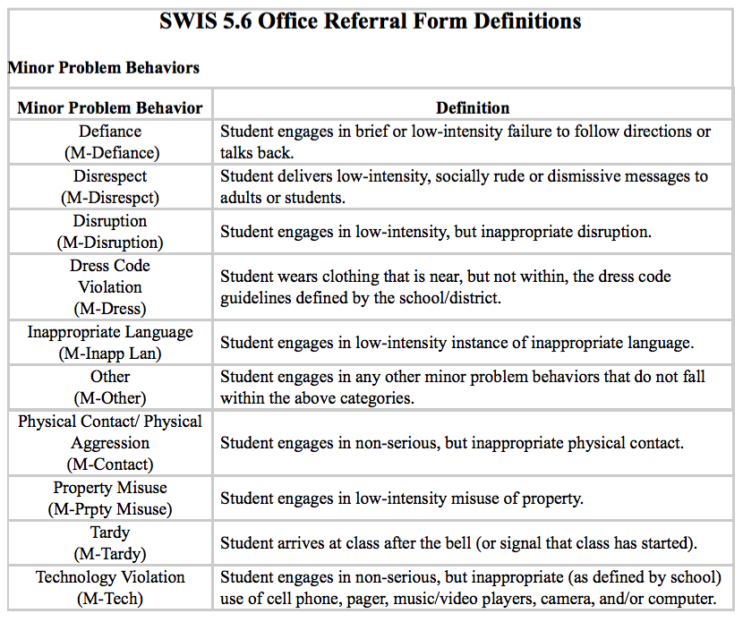

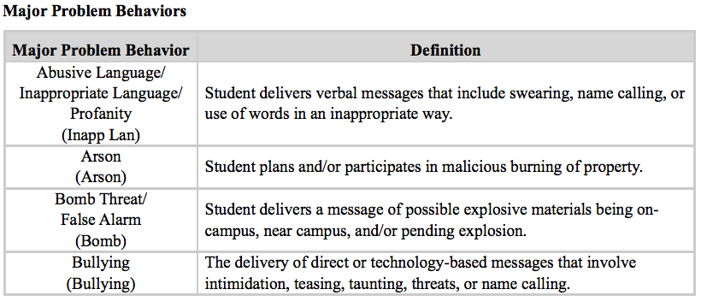

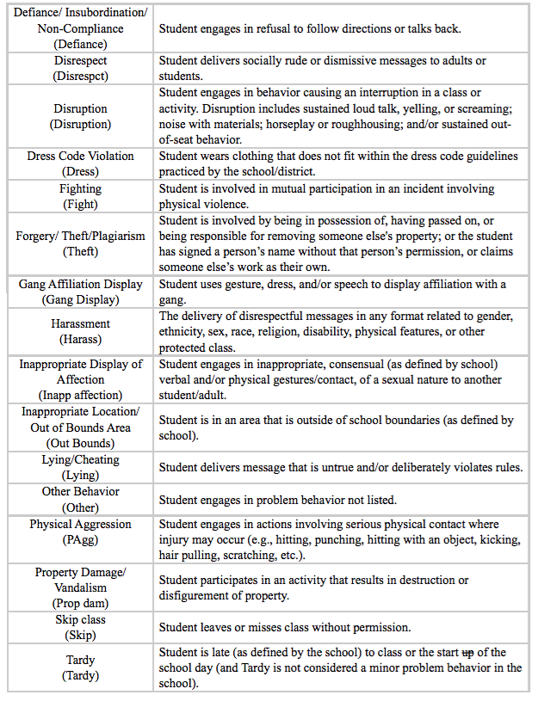

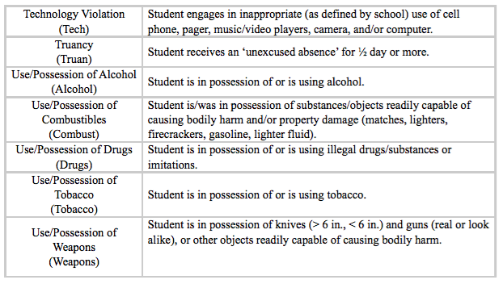
Activity 2: Problem Behavior Definitions
Do you have clear and shared definitions of all problem behaviors?

Guiding Questions:
- Why would having a clear and shared definition of each behavior be important among all stakeholders (staff, students, families, communities)?
- What impact would agreements about classroom managed vs office managed behaviors have on our school community?

Activity with Staff:
Share discipline data (consider including data disaggregated by gender, ethnicity/race, and special education) identifying the top 5 behaviors showing up in your data and any descriptive data that describes what happened.
- Ask staff: What do you notice?
- Arrange staff in vertical teams (multiple perspectives)
- Assign each team one of the top 5 behaviors and provide them with the descriptive data
- Ask teams to draw the t-chart below with identified behavior at the top
- Ask teams to identify behavioral examples of what minor and major types of this behavior look and sound like

Problem Behaviors are Defined
Is there a common understanding among staff?
Behavior: _____________________________________
Classroom-Managed (Minor): | Office Managed (Major):
What does this behavior look like? | What does this behavior look like?
What does this behavior sound like? | What does this behavior sound like?

Discipline Process
Continuum of Support for Discouraging Inappropriate Behavior
Office Discipline Referral

- Write pass or escort student to office
- Teacher Complete ODR/ Time out of Class Form

Administrator Actions:

- Administrator assesses, problem solves
- Objective: Teach, learn, return to academic instruction as quickly as possible
- Strategies:
- Practice behavior expectations
- Re-Teach in setting
- Problem-solving team
- Conference with families
- Restorative practice strategies including…
Behavior
Improves

Office-Managed (major)
Ongoing Teaching and Encouraging of Expectations and Building Relationships

Inappropriate
Behavior Occurs

SAMPLE
Classroom-Managed (minor)

- Planned Ignoring
- Physical Proximity
- Signal/Non-verbal Cue
- Direct Eye Contact
- Praise (BSPS) Appropriate Behavior in Others
- Re-direct
- Re-teach
Continue teaching, encouraging, and building relationships; Think function (why)

Behavior
Improves

Steps of Specific and Contingent Error Correction:

- Respectfully address student
- Describe inappropriate behavior
- Describe expected behavior/rule
- Link to expectation on Matrix
- Redirect back to appropriate behavior
- Support for Classroom Procedure/Routine
- Differential Reinforcement
- Specific and Contingent Error Correction
- Provide Choice
- Conference with Student

If student behavior persists, begin using minor ODR (classroom-managed) for data collection to inform problem solving and decision-making.
Continue teaching, encouraging, and building relationships; Think function (why)

Behavior
Improves

Problem solving with:
- Tier II Support
- Family
- Grade level team
- Department team
- Student assistance team

If the behavior doesn’t decrease in intensity and/or frequency, then enlist the support of the administrator via minor ODR form

Activity 3: Discipline Process: Flowchart

Discipline Process
Continuum of Support for Discouraging Inappropriate Behavior
Classroom-Managed (minor)
Office-Managed (major)

Ongoing Teaching and Encouraging of Expectations and Building Relationships

Office Discipline Referral

Inappropriate
Behavior Occurs

Behavior
Improves

Behavior
Improves

Behavior
Improves

Ac

Activity 4: Considerations for Consequences

(Adapted from Missouri PBIS New Team Workbook Chapter 6)

- Discuss the following 3 selections with your team, (e.g., jigsaw activity, silent reading and group discussion).
CONSEQUENCES ARE NOT PUNITIVE. Consequences paired with teaching of the alternative or desirable behavior can heighten behavior change. Effective consequences result in greater learning and often involve learning tasks or opportunities directly related to the inappropriate behavior. In this manner, they are similar to what we do when students are not making academic progress. We find additional practice or activities to help them learn. Role-play or practice, reflecting on the behavior and the alternative, arranging a situation for the student to demonstrate the skill, and making amends for behavior that impacted others are all wonderful learning-based consequences. Effective consequences maintain student dignity and invite the student to take responsibility for his/her behavior and be a part of the solution.
Even though consequences for inappropriate behavior are intended to be educational, they are also mildly aversive. That is, they require effort and should leave little incentive to repeat the inappropriate behavior.
Thoughts …

CONSISTENCY, NOT SIZE IS IMPORTANT. It is not the size of the consequence that promotes behavior change, but the certainty that something will be done. This is a common misunderstanding as educators often look for a bigger consequence – that big one that will stop the behavior. When students passing in the hallways see that all educators consistently stop students to address the same violations of procedures, they will more likely use the expected behavior. It is important to note that increasingly harsh consequences can lead to antisocial behavior. An overemphasis on punishment focuses the attention of the student on the looming consequence and limits their consideration of the effect their behavior has on others or themselves (Alberto & Troutman, 2012).
Thoughts …

CONSEQUENCES SHOULD BE SELECTED INDIVIDUALLY. Consequences are best when they are selected to fit the individual, the specific behavior and setting, the frequency, or the severity of the behavior. What fits one may not fit another. For the middle school student who was rude to a substitute, perhaps having her determine how students should treat guest teachers and then teaching her peers is a powerful consequence. For the student having difficulty getting along at recess with a peer, planning an activity that they can successfully do together might be effective. In both of these examples the standard of respect is being consistently upheld, but the consequences are personalized.
Schools often get caught up in a desire to be fair. Fairness and consistency is achieved through clear expectations and standards that are upheld for all. Consequences in upholding those standards may be different as appropriate for the student. Fairness doesn’t mean that everyone gets the same thing. Fairness means that everyone gets what they need in order to be successful and meet the standard.
Thoughts …

Activity 5: Considerations for Alternatives to Suspension
Peterson, R. L. (2005). Ten alternatives to suspension. Impact: Feature Issue on Fostering Success in School and Beyond for Students With Emotional/Behavioral Disorders, 18(2).

Host environments that support positive behavior, positive interactions, appropriate instruction, and active supervision use:
- Problem solving and contracting to remind student to engage in problem solving process and to identify reinforcers and consequences
- Restitution
- Re-teaching or instruction on topics related to student behavior
- Family involvement to help problem solve and identify ways to increase communication
- Counseling
- Community service
- Behavior monitoring, self-management strategies
- Coordinated behavior plans based on hypothesized function of the behavior
- Appropriate in-school suspension (e.g., includes academic tutoring, explicit instruction on skill-building, clearly defined procedure for returning to class contingent on progress and/or behavior
- Mediation (e.g. peer mediation)
Thoughts …
What are you already using as alternatives to suspension?

What considerations might be appropriate for your school community?

Activity 6: Discipline Flowchart and Process for handling Major Office Discipline Referrals

Review the guiding question below. Fill in the corresponding boxes in the Discipline Flowchart Template in Activity 3.

Guiding Questions for Major ODRs:
- Is the current discipline policy and flowchart/process documented in the staff handbook?
- What are the teacher expectations for Major ODRs?
- What procedure does the office/dean/administrator follow for a Major Discipline Referral?
- What is the main goal of the office/dean/administrator when addressing a major behavior?

Review the additional guiding questions below. Consider adding action steps to your overall action plan:

Guiding Questions for Implementing the Flowchart in your School:
- Do all staff members know what to do when they observe a minor behavior?
- Do all staff members know what to do when they observe a major behavior?
- Is there consistency among the staff in how they address and process behaviors?
- When and how will you introduce all staff to the discipline flowchart?
- How will staff reference the flowchart when it is needed?
- Who/how will you teach the continuum of strategies to respond to inappropriate behavior to all staff?
- How will you ensure all staff follow the discipline flowchart?

Activity 7: Constructing Your Office Referral Form
- Review resources below for constructing your Office Referral
- Review sample data collection ODR form
- Review your current office discipline referral and identify data fields to add
- Identify data collection form and process for classroom-managed behaviors (minor)
- Identify when and how you will train and support staff in using data collection tools

Resources
Do your data collection tools have all the information you need to make data-informed decisions?
- Student’s name  - Problem behavior (with designation of staff managed or office managed)  - Date  - Possible motivation  - Time of incident  - What was happening before the behavior (antecedent)? | - Location of incident  - Possible consequences  - Student’s teacher  - Administrative decision  - Student’s grade level  - Other comments (keep brief)  - Referring staff name  - Others involved
Office Referral Documentation  Once you have clearly defined what behaviors are office-managed, you will want to develop an office referral form that provides a count of the number of behavior incidents, the types of behavior infractions, the time and location of their occurrence, and the students and staff who were involved. This allows you to document lost instructional time, problematic locations and times, and identify trends across the year. These contextual factors need to be included on your office referral form. | Teacher’s Role in Office Referral Process  - Work consistently to address staff-managed behaviors and refer students according to the definitions for office-managed behaviors  - Thoroughly complete the Office Referral Form (ODR); be prepared to meet with the administrator for follow up  - Send the student to the office; use an escort or call the office if safety is an issue  - Notify the office when student has been sent  - Be prepared to visit with the administrator to determine restitution, make up work, additional interventions, etc.  - Accept the student back into class when the administrator determines readiness and ensure a smooth transition for the student
Preparing Staff  You will want to prepare staff for using the office referral form consistently. This will involve their understanding the rationale for the form, their role in making a referral, and what they can expect will occur in the referral process (e.g., problem resolution, possible consequences, data entry, visits to referring staff, etc.). The teacher’s role in making an office referral. | Administrator Procedures  For the majority of routine problems referred to the office, the administrator or designee will calm the student, review the referring problem, re-teach alternative behaviors for handling the problem (e.g., teaching matrix behaviors, deliver consequences, and help prepare the student for a successful return to the classroom or program). Advance planning should occur for handling crisis or illegal infractions and how law enforcement and crisis teams will work with the school staff

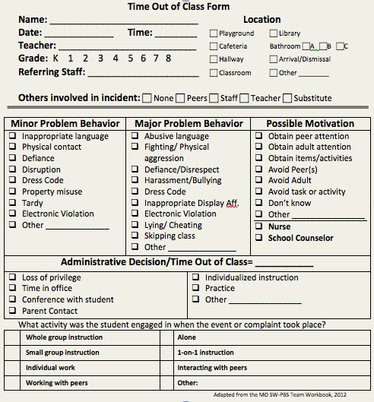

TIER I TRAINING: IMPLEMENTATION:
Problem Behavior Definitions and Discipline Policies

Tiered Fidelity Inventory: Tier I Features
1.5 Problem Behavior Definitions:
School has clear definitions for behaviors that interfere with academic and social success and a clear policy/procedure (e.g., flowchart) for addressing office-managed versus staff-managed problems.
1.6 Discipline Policies:
School policies and procedures describe and emphasize proactive, instructive, and/or restorative approaches to student behavior that are implemented consistently.

Tiered Fidelity Inventory: Tier I Features
1.8 Classroom Procedures:
Tier I features (school-wide expectations, routines, acknowledgements, in-class continuum of consequences) are implemented within classrooms and consistent with school-wide systems.
Action Items
TFI | Action Item  (Not In Place; Partially; Fully In Place ->) | NI | PI | FI
1.5 | Engage staff in facilitated process to define behaviors and differentiate between office-managed and classroom-managed behavioral examples
1.5 | Create a narrative and/or flowchart to establish discipline procedures
1.5 | Develop data collection forms for office-managed and classroom-managed behavioral examples and plan for training staff
1.5 | Ensure data form fields exist for meaningful decision-making
1.5 | Define a continuum of appropriate instructional responses to office-managed and classroom-managed behavioral examples
1.6 | Identify school policies and procedures that describe and emphasize proactive, instructive, and/or restorative approaches to student behavior that are implemented consistently.
1.8 | Procedures exist for tracking classroom behavior problems
1.8 | Classrooms have a range of interventions for problem behavior that are documented and consistently delivered.

Tiered Fidelity Inventory – Tier 1
Tier 1 Subscale and Feature | Definition |  | Possible Data Sources | Criteria  0=Not implemented; 1=Partially implemented; 2=Fully implemented |  | Score 0, 1, 2
TEAMS
1.1 Team Composition | Tier I team includes a Tier I systems coordinator, a school administrator, a family member, and individuals able to provide (a) applied behavioral expertise, (b) coaching expertise, (c) knowledge of student academic and behavior patterns, (d) knowledge about the operations of the school across grade levels and programs, and for high schools, (e) student representation. |  | - School organizational chart  - Tier I team meeting minutes | 0 = Tier I team does not exist or does not include coordinator, school administrator, or individuals with applied behavioral expertise  1 = Tier I team exists, but does not include all identified roles or attendance of these members is below 80%  2 = Tier I team exists with coordinator, administrator, and all identified roles represented, AND attendance
1.2 Team Operating Procedures | Tier I team meets at least monthly and has (a) regular meeting format/agenda,  (b) minutes, (c) defined meeting roles, and (d) a current action plan. |  | - Tier I team meeting agendas and minutes  - Tier I meeting roles descriptions  - Tier I action plan | 0 = Tier I team does not use regular meeting format/ agenda, minutes, defined roles, or a current action plan  1= Tier I team has at least 2 but not all 4 features  2 = Tier I team meets at least monthly and uses regular meeting format/agenda, minutes, defined roles, AND has a current action plan
IMPLEMENTATION
1.3 Behavioral Expectations | School has five or fewer positively stated behavioral expectations and examples by setting/location for student and staff behaviors (i.e., school teaching matrix) defined and in place. |  | - TFI Walkthrough Tool  - Staff handbook  - Student handbook | 0 = Behavioral expectations have not been identified, are not all positive, or are more than 5 in number  1 = Behavioral expectations identified but may not include a matrix or be posted  2 = Five or fewer behavioral expectations exist that are positive, posted, and identified for specific settings (i.e., matrix) AND at least 90% of staff can list at least 67% of the expectations
1.4 Teaching Expectations | Expected academic and social behaviors are taught directly to all students in classrooms and across other campus settings/locations. |  | - TFI Walkthrough Tool  - Professional development calendar  - Lesson plans  - Informal walkthroughs | 0 = Expected behaviors are not taught  1 = Expected behaviors are taught informally or inconsistently  2 = Formal system with written schedules is used to teach expected behaviors directly to students across classroom and campus settings AND at least 70% of students can list at least 67% of the expectations
1.5 Problem Behavior Definitions | School has clear definitions for behaviors that interfere with academic and social success and a clear policy/ procedure (e.g., flowchart) for addressing office-managed versus staff-managed problems. |  | - Staff handbook  - Student handbook  - School policy  - Discipline flowchart | 0 = No clear definitions exist, and procedures to manage problems are not clearly documented  1 = Definitions and procedures exist but are not clear and/or not organized by staff- versus office-managed problems  2 = Definitions and procedures for managing problems are clearly defined, documented, trained, and share with families
1.6 Discipline Policies | School policies and procedures describe and emphasize proactive, instructive, and/ or restorative approaches to student behavior that are implemented consistently. |  | - Discipline policy  - Student handbook  - Code of conduct  - Informal administrator interview | 0 = Documents contain only reactive and punitive consequences  1 = Documentation includes and emphasizes proactive approaches  2 = Documentation includes and emphasizes proactive approaches AND administrator reports consistent use
1.7 Professional Development | A written process is used for orienting all faculty/staff on 4 core Tier I SWPBIS practices: (a) teaching school-wide expectations, (b) acknowledging appropriate behavior, (c) correcting errors, and (d) requesting assistance. |  | - Professional development calendar  - Staff handbook | 0 = No process for teaching staff is in place  1 = Process is informal/unwritten, not part of professional development calendar, and/or does not include all staff or all 4 core Tier I practices  2 = Formal process for teaching all staff all aspects of Tier I system, including all 4 core Tier I practices
1.8 Classroom Procedures | Tier I features (school-wide expectations, routines, acknowledgements, in-class continuum of consequences) are implemented within classrooms and consistent with school-wide systems. |  | - Staff handbook  - Informal walkthroughs  - Progress monitoring  - Individual classroom data | 0 = Classrooms are not implementing Tier I  1 = Classrooms are informally implementing Tier I but no formal system exists  2 = Classrooms are formally implementing all core Tier I features, consistent with school-wide expectations
1.9 Feedback and Acknowledge-ment | A formal system (i.e., written set of procedures for specific behavior feedback that is [a] linked to school-wide expectations and [b] used across settings and within classrooms) is in place and used by at least 90% of a sample of staff and received by at least 50% of a sample of students. |  | - TFI Walkthrough Tool  - Staff Handbook | 0 = No formal system for acknowledging students  1 = Formal system is in place and is used by at least 90% of staff OR received by at least 50% of students  2 = Formal system for acknowledging student behavior is used by at least 90% of staff AND received by at least 50% of students
1.10 Faculty Involvement | Faculty are shown school- wide data regularly and provide input on universal foundations (e.g., expectations, acknowledgements, definitions, consequences) at least every 12 months. |  | - PBIS Self-Assessment Survey  - Informal surveys  - Staff meeting minutes  - Team meeting minutes | 0 = Faculty are not shown data at least yearly and do not provide input  1 = Faculty have been shown data more than yearly OR have provided feedback on Tier I foundations within the past  12 months but not both  2 = Faculty are shown data at least 4 times per year AND have provided feedback on Tier I practices within the past 12 months
1.11 Student/ Family/ Community Involvement | Stakeholders (students, families, and community members) provide input on universal foundations (e.g., expectations, consequences, acknowledgements) at  least every 12 months. |  | - Surveys  - Voting results from parent/ family meeting  - Team meeting minutes | 0 = No documentation (or no opportunities) for stakeholder feedback on Tier I foundations  1 = Documentation of input on Tier I foundations, but not within the past 12 months or input but not from all types of stakeholders  2 = Documentation exists that students, families, and community members have provided feedback on Tier I practices within the past 12 months
EVALUATION
1.12 Discipline Data | Tier I team has instantaneous access to graphed reports summarizing discipline data organized by the frequency of problem behavior events by behavior, location, time of day, and by individual student. |  | - School policy  - Team meeting minutes  - Student outcome data | 0 = No centralized data system with ongoing decision making exists  1 = Data system exists but does not allow instantaneous access to full set of graphed reports  2 = Discipline data system exists that allows instantaneous access to graphs of frequency of problem behavior events by behavior, location, time of day, and student
1.13 Data-based Decision Making | Tier I team reviews and uses discipline data and academic outcome data (e.g., Curriculum-Based Measures, state tests) at least monthly for decision-making. |  | - Data decision rules  - Staff professional development calendar  - Staff handbook  - Team meeting minutes | 0 = No process/protocol exists, or data are reviewed but not used  1 = Data reviewed and used for decision-making, but less than monthly  2 = Team reviews discipline data and uses data for decision-making at least monthly. If data indicate an academic or behavior problem, an action plan is developed to enhance or modify Tier I supports
1.14 Fidelity Data | Tier I team reviews and uses SWPBIS fidelity (e.g., SET, BoQ, TIC, SAS, Tiered Fidelity Inventory) data at least annually. |  | - School policy  - Staff handbook  - School newsletters  - School website | 0 = No Tier I SWPBIS fidelity data collected  1 = Tier I fidelity collected informally and/or less often than annually  2 = Tier I fidelity data collected and used for decision making annually
1.15 Annual Evaluation | Tier I team documents fidelity and effectiveness (including on academic outcomes) of Tier I practices at least annually (including year- by-year comparisons) that are shared with stakeholders (staff, families, community, district) in a usable format. |  | - Staff, student, and family surveys  - Tier I handbook  - Fidelity tools  - School policy  - Student outcomes  - District reports  - School newsletters | 0 = No evaluation takes place, or evaluation occurs without data  1 = Evaluation conducted, but not annually, or outcomes are not used to shape the Tier I process and/ or not shared with stakeholders  2 = Evaluation conducted at least annually, and outcomes (including academics) shared with stakeholders, with clear alterations in process based on evaluation
Total Score | Items/Points | Points Award/Points Possible |  |  | Percentage of PBIS Implementation
Tier 1 | 1-15 / 30 points | ____________ / 30

PBIS Action Plan:

Directions:
- Complete the following action plan to document steps toward implementation of PBIS.
- See Action Items at the end of each module in the workbook to identify action steps for inclusion in plan.
- Add additional action steps as identified by team.

Subscale and  Tier 1 Features | Score from TFI:  0, 1, 2 | Action Steps: |  | Who? |  | When?
TEAMS
- Team Composition  DAY 1 |  | 1.  PD Plan:
- Team Operating Procedures  DAY 1 |  | 1.  PD Plan:
IMPLEMENTATION
- Behavioral Expectations  DAY 2 |  | 1.  PD Plan:
1.4 Teaching Expectations |  | 1.  PD Plan:
1.5 Problem Behavior Definitions |  | 1.  PD Plan:
1.6 Discipline Policies |  | 1.  PD Plan:
1.7 Professional Development |  | 1.
1.8 Classroom Procedures  DAY 2 and DAY 5 |  | 1.  PD Plan:
1.9 Feedback and Acknowledgement |  | 1.  PD Plan:
1.10 Faculty Involvement |  | 1.  PD Plan:
1.11 Student/Family/ Community Involvement |  | 1.  PD Plan:
EVALUATION
1.12 Discipline Data |  | 1.  PD Plan:
1.13 Data-based Decision Making |  | 1.  PD Plan:
1.14 Fidelity Data |  | 1.  PD Plan:
1.15 Annual Evaluation |  | 1.  PD Plan:
OTHER ACTION STEPS: |  |  | Who? |  | When?

TIER I TRAINING: IMPLEMENTATION
Classroom
Activity 1: Graffiti Wall
At your table create a summary of the installation of your SWPBIS (Tier 1) system that addresses the Big Ideas of PBIS. Here are the requirements:
  - Every person at your table must contribute to the creation of the poster
  - Use only pictures
  - You only have 5 minutes

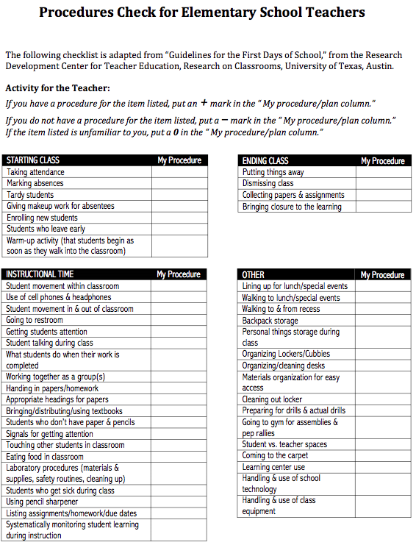

TIER I TRAINING: IMPLEMENTATION
Faculty Involvement and Student/Family/Community Involvement
Activity 1a: Communication System
Guiding Qu

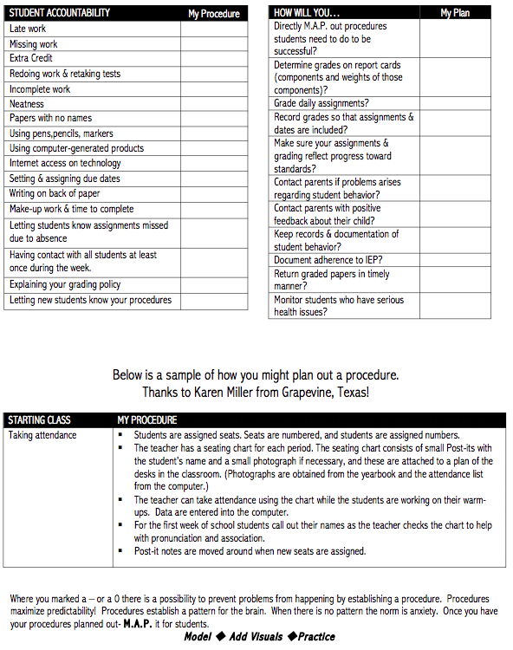

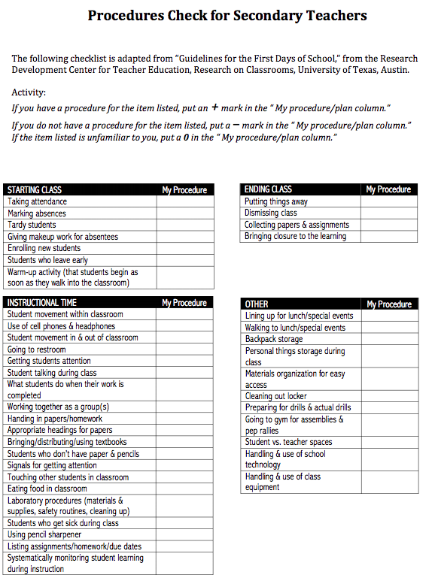

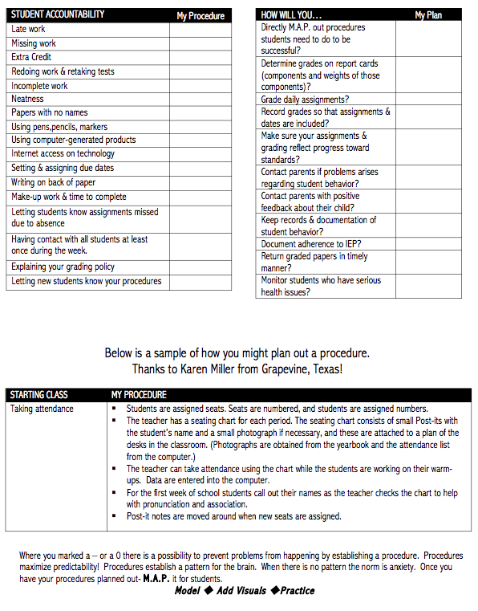

Activity 2: Classroom Expectations and Routines
Refer back to pages 18-19 for classroom activities.

Activity 3: Opportunities to Respond
At your table come up with a list of ways you give students opportunities to respond. Record each idea. Think of a brief plan to teach one of these strategies to staff.

Classroom Management: Self-Assessment

Teacher__________________________ Rater_______________________ |  |  | Date_____________
Instructional Activity |  |  | Time Start_________  Time End _________
Tally each Positive Student Contacts | Total # | Tally each Negative Student Contacts |  | Total #
Ratio of Positives to Negatives: _____ to 1

Classroom Management Practice | Rating
- I have arranged my classroom to minimize crowding and distraction | Yes No
- I have maximized structure and predictability in my classroom (e.g., explicit classroom routines, specific directions, etc.). | Yes No
- I have posted, taught, reviewed, and reinforced 3-5 positively stated expectations (or rules). | Yes No
- I provided more frequent acknowledgement for appropriate behaviors than inappropriate behaviors (See top of page). | Yes No
- I provided each student with multiple opportunities to respond and participate during instruction. | Yes No
- My instruction actively engaged students in observable ways (e.g., writing, verbalizing) | Yes No
- I actively supervised my classroom (e.g., moving, scanning) during instruction. | Yes No
- I ignored or provided quick, direct, explicit reprimands/redirections in response to inappropriate behavior. | Yes No
- I have multiple strategies/systems in place to acknowledge appropriate behavior (e.g., class point systems, praise, etc.). | Yes No
- In general, I have provided specific feedback in response to social and academic behavior errors and correct responses. | Yes No
Overall classroom management score:  10-8 “yes” = “Super”  7-5 “yes” = “So-So”  <5 “yes” = “Improvement Needed” | # Yes________
Action Planning
The purposes of this assessment are to (a) determine the extent to which effective general classroom management practices are in place and (b) develop an action plan for enhancement/maintenance based on this information. This assessment and action plan can be completed as a “self-assessment” or by an observer.
- Pick a teacher-led/directed activity that has a specific learning outcome/objective.
- During the activity, count number of positive and negative student contacts that occur during the activity.
- After the activity,
  - Sum the number of positive and negative contacts and calculate the ratio of positive to negative contacts.
  - Assess whether each classroom management practice was evident.
  - Sum the number of “yes” to determine overall classroom management score.
  - Based on your score, develop an action plan for enhancement/maintenance.

Action Plan
# | Current Level of Performance | Enhancement/Maintenance Strategies
https://www.pbis.org/resource/174/classroom-management-self-assessment-revised-version-april-7-2006

Full Walk Through Tool Can Be Found At:
http://www.laspdg.org/files/Classroom%20Walkthrough%20Examples.pdf

Activity 4: Classroom Coaching
Discuss how classroom coaching around behavior might look at your building.
- Who could you utilize?
- How would this fit in to how you already support teachers?
- What tools and resources are available at your site?

Can be found at:

http://www.pbis.org/common/cms/files/pbisresources/Supporting and Responding to Behavior.pdf

Activity 5: Classroom Tool
- On a sticky note write the problem behavior you experience the most frequently.
- Put your sticky note in the center of your table.
- Organize the sticky notes by similar behaviors looking for overlap.
- Coach read the sticky notes.
- Choose one or two behaviors from the center of the table.
- Explore the Supporting and Responding to Behavior guide to find strategies to help staff respond supportively to your chosen behaviors.
- Write the problem behavior on top of your poster paper and then 3 strategies you found in the Supporting and Responding to Behavior staff could use

TIER I TRAINING: IMPLEMENTATION
Classroom

Tiered Fidelity Inventory: Tier I Features
1.8 Classroom Procedures:
Tier I features (school-wide expectations, routines, acknowledgements, in-class continuum of consequences) are implemented within classrooms and consistent with school-wide systems.

TFI | Action Item  (Not In Place; Partially; Fully In Place ->) | NI | PI | FI
1.8 | Classroom rules are defined, aligned to school-wide expectations, and are posted in classrooms.
1.8 | Expected classroom behaviors and routines are taught
1.8 | Classroom routines and procedures are explicitly identified for activities where problems often occur (e.g. entering class, asking questions, sharpening pencil, using restroom, dismissal)
1.8 | Classroom teachers use immediate and specific praise
1.8 | Acknowledgement of students demonstrating adherence to classroom rules occurs more frequently than acknowledgement of inappropriate behavior
1.8 | Classrooms have a range of interventions for problem behavior that are documented and consistently delivered.
1.8 | Procedures exist for tracking classroom behavior problems

TIER I TRAINING: IMPLEMENTATION
Faculty Involvement and Student/Family/Community Involvement
Activity 1a: Communication System
Guiding Questions:
- How will you engage staff in the implementation of PBIS?
- How will you facilitate professional learning for “Rethinking Discipline?”
- How will you share your vision?
- Have you reviewed your data?
- How will you showcase results?

Record your team’s discussion:

Activity 1b: Communication System
Consider what communication structures for sharing information and data you have in place now and discuss what opportunities you have yet to explore.
Directions:
- Starting with the facilitator, and moving clockwise, each person share out a time/opportunity your school could share important school data/PBIS information.
  - (Think about what structure you have in place now and “outside” the box thinking of what may be opportunities you haven’t explored yet)
- Recorder, document the team’s discussions. Communicator, share out after the activity.

Activity 2: Families
What do you already do to get families in the door? How can you connect this to PBIS?

Activity 3: Planning for Stakeholder Input and Feedback
Identify how your team will involve all your stakeholders in developing the Universal Foundations.
How will you receive their input, as well as their continued feedback?

 |  | Universal Foundations
 |  | Expectations  and Rules  (Teaching Matrices) | Initial and on-going instruction on expectations | Acknowledgement Program | Discipline (problem behavior definitions, policies, procedures)
Stakeholders | Students
 | Families
 | Communities

TIER I TRAINING: IMPLEMENTATION
Faculty Involvement and Student/Family/Community Involvement

Tiered Fidelity Inventory: Tier I Features
1.10 Faculty Involvement: Faculty are shown school-wide data regularly and provide input on universal foundations (e.g., expectations, acknowledgements, definitions, consequences) at least every 12 months
1.11 Student/Family/Community Involvement:
Stakeholders (students, families, and community members) provide input on universal foundations (e.g., expectations, consequences, acknowledgements) at least every 12 months.

Action Items
TFI | Action Item  (Not In Place; Partially; Fully In Place ->) | NI | PI | FI
1.10 | School-Wide behavioral data is shared with faculty regularly
1.10 | Faculty involved in establishing and reviewing goals
1.10 | Faculty feedback is obtained throughout the year
1.11 | Plans for involving families/communities are developed and implemented
1.10, 1.11 | Data informs decisions (e.g., staff surveys, fidelity assessments, climate surveys, etc.)
1.10, 1.11 | Surveys are developed with dates to administer to staff, students, and families

Tiered Fidelity Inventory (TFI)
Directions: The TFI is intended to be completed by members of a school’s System Planning Team, with the active presence and guidance of an external [district] SWPBIS coach.

Tiered Fidelity Inventory – Tier 1
Tier 1 Subscale and Feature | Definition | Possible Data Sources | Criteria  0=Not implemented; 1=Partially implemented; 2=Fully implemented | Score 0, 1, 2
TEAMS
1.1 Team Composition | Tier I team includes a Tier I systems coordinator, a school administrator, a family member, and individuals able to provide (a) applied behavioral expertise, (b) coaching expertise, (c) knowledge of student academic and behavior patterns, (d) knowledge about the operations of the school across grade levels and programs, and for high schools, (e) student representation. | School organizational chart  Tier I team meeting minutes | 0 = Tier I team does not exist or does not include coordinator, school administrator, or individuals with applied behavioral expertise  1 = Tier I team exists, but does not include all identified roles or attendance of these members is below 80%  2 = Tier I team exists with coordinator, administrator, and all identified roles represented, AND attendance
1.2 Team Operating Procedures | Tier I team meets at least monthly and has (a) regular meeting format/agenda,  (b) minutes, (c) defined meeting roles, and (d) a current action plan. | Tier I team meeting agendas and minutes  Tier I meeting roles descriptions  Tier I action plan | 0 = Tier I team does not use regular meeting format/ agenda, minutes, defined roles, or a current action plan  1= Tier I team has at least 2 but not all 4 features  2 = Tier I team meets at least monthly and uses regular meeting format/agenda, minutes, defined roles, AND has a current action plan
IMPLEMENTATION
1.3 Behavioral Expectations | School has five or fewer positively stated behavioral expectations and examples by setting/location for student and staff behaviors (i.e., school teaching matrix) defined and in place. | TFI Walkthrough Tool  Staff handbook  Student handbook | 0 = Behavioral expectations have not been identified, are not all positive, or are more than 5 in number  1 = Behavioral expectations identified but may not include a matrix or be posted  2 = Five or fewer behavioral expectations exist that are positive, posted, and identified for specific settings (i.e., matrix) AND at least 90% of staff can list at least 67% of the expectations
1.4 Teaching Expectations | Expected academic and social behaviors are taught directly to all students in classrooms and across other campus settings/locations. | TFI Walkthrough Tool  Professional development calendar  Lesson plans  Informal walkthroughs | 0 = Expected behaviors are not taught  1 = Expected behaviors are taught informally or inconsistently  2 = Formal system with written schedules is used to teach expected behaviors directly to students across classroom and campus settings AND at least 70% of students can list at least 67% of the expectations
1.5 Problem Behavior Definitions | School has clear definitions for behaviors that interfere with academic and social success and a clear policy/ procedure (e.g., flowchart) for addressing office-managed versus staff-managed problems. | Staff handbook  Student handbook  School policy  Discipline flowchart | 0 = No clear definitions exist, and procedures to manage problems are not clearly documented  1 = Definitions and procedures exist but are not clear and/or not organized by staff- versus office-managed problems  2 = Definitions and procedures for managing problems are clearly defined, documented, trained, and share with families
1.6 Discipline Policies | School policies and procedures describe and emphasize proactive, instructive, and/ or restorative approaches to student behavior that are implemented consistently. | Discipline policy  Student handbook  Code of conduct  Informal administrator interview | 0 = Documents contain only reactive and punitive consequences  1 = Documentation includes and emphasizes proactive approaches  2 = Documentation includes and emphasizes proactive approaches AND administrator reports consistent use
1.7 Professional Development | A written process is used for orienting all faculty/staff on 4 core Tier I SWPBIS practices: (a) teaching school-wide expectations, (b) acknowledging appropriate behavior, (c) correcting errors, and (d) requesting assistance. | Professional development calendar  Staff handbook | 0 = No process for teaching staff is in place  1 = Process is informal/unwritten, not part of professional development calendar, and/or does not include all staff or all 4 core Tier I practices  2 = Formal process for teaching all staff all aspects of Tier I system, including all 4 core Tier I practices
1.8 Classroom Procedures | Tier I features (school-wide expectations, routines, acknowledgements, in-class continuum of consequences) are implemented within classrooms and consistent with school-wide systems. | Staff handbook  Informal walkthroughs  Progress monitoring  Individual classroom data | 0 = Classrooms are not implementing Tier I  1 = Classrooms are informally implementing Tier I but no formal system exists  2 = Classrooms are formally implementing all core Tier I features, consistent with school-wide expectations
1.9 Feedback and Acknowledge-ment | A formal system (i.e., written set of procedures for specific behavior feedback that is [a] linked to school-wide expectations and [b] used across settings and within classrooms) is in place and used by at least 90% of a sample of staff and received by at least 50% of a sample of students. | TFI Walkthrough Tool  Staff Handbook | 0 = No formal system for acknowledging students  1 = Formal system is in place and is used by at least 90% of staff OR received by at least 50% of students  2 = Formal system for acknowledging student behavior is used by at least 90% of staff AND received by at least 50% of students
1.10 Faculty Involvement | Faculty are shown school- wide data regularly and provide input on universal foundations (e.g., expectations, acknowledgements, definitions, consequences) at least every 12 months. | PBIS Self-Assessment Survey  Informal surveys  Staff meeting minutes  Team meeting minutes | 0 = Faculty are not shown data at least yearly and do not provide input  1 = Faculty have been shown data more than yearly OR have provided feedback on Tier I foundations within the past  12 months but not both  2 = Faculty are shown data at least 4 times per year AND have provided feedback on Tier I practices within the past 12 months
1.11 Student/ Family/ Community Involvement | Stakeholders (students, families, and community members) provide input on universal foundations (e.g., expectations, consequences, acknowledgements) at  least every 12 months. | - Surveys  - Voting results from parent/ family meeting  - Team meeting minutes | 0 = No documentation (or no opportunities) for stakeholder feedback on Tier I foundations  1 = Documentation of input on Tier I foundations, but not within the past 12 months or input but not from all types of stakeholders  2 = Documentation exists that students, families, and community members have provided feedback on Tier I practices within the past 12 months
EVALUATION
1.12 Discipline Data | Tier I team has instantaneous access to graphed reports summarizing discipline data organized by the frequency of problem behavior events by behavior, location, time of day, and by individual student. | - School policy  - Team meeting minutes  - Student outcome data | 0 = No centralized data system with ongoing decision making exists  1 = Data system exists but does not allow instantaneous access to full set of graphed reports  2 = Discipline data system exists that allows instantaneous access to graphs of frequency of problem behavior events by behavior, location, time of day, and student
1.13 Data-based Decision Making | Tier I team reviews and uses discipline data and academic outcome data (e.g., Curriculum-Based Measures, state tests) at least monthly for decision-making. | - Data decision rules  - Staff professional development calendar  - Staff handbook  - Team meeting minutes | 0 = No process/protocol exists, or data are reviewed but not used  1 = Data reviewed and used for decision-making, but less than monthly  2 = Team reviews discipline data and uses data for decision-making at least monthly. If data indicate an academic or behavior problem, an action plan is developed to enhance or modify Tier I supports
1.14 Fidelity Data | Tier I team reviews and uses SWPBIS fidelity (e.g., SET, BoQ, TIC, SAS, Tiered Fidelity Inventory) data at least annually. | - School policy  - Staff handbook  - School newsletters  - School website | 0 = No Tier I SWPBIS fidelity data collected  1 = Tier I fidelity collected informally and/or less often than annually  2 = Tier I fidelity data collected and used for decision making annually
1.15 Annual Evaluation | Tier I team documents fidelity and effectiveness (including on academic outcomes) of Tier I practices at least annually (including year- by-year comparisons) that are shared with stakeholders (staff, families, community, district) in a usable format. | - Staff, student, and family surveys  - Tier I handbook  - Fidelity tools  - School policy  - Student outcomes  - District reports  - School newsletters | 0 = No evaluation takes place, or evaluation occurs without data  1 = Evaluation conducted, but not annually, or outcomes are not used to shape the Tier I process and/ or not shared with stakeholders  2 = Evaluation conducted at least annually, and outcomes (including academics) shared with stakeholders, with clear alterations in process based on evaluation

Note: See www.pbisapps.org for Tiers 2 and 3 of the TFI at https://www.pbisapps.org/Resources/SWIS Publications/SWPBIS Tiered Fidelity Inventory (TFI).pdf
PBIS Action Plan:
(Alternate action plan with pre-completed recommendations available in Appendix A)

Directions:
- Complete the following action plan to document steps toward implementation of PBIS.
- See Action Items at the end of each module in the workbook to identify action steps for inclusion in plan.
- Add additional action steps as identified by team.

Subscale and  Tier 1 Features | Score from TFI:  0, 1, 2 | Action Steps: | Who? | When?
TEAMS
1.1 Team Composition |  | 1.  PD Plan:
1.2 Team Operating Procedures |  | 1.  PD Plan:
IMPLEMENTATION
1.3 Behavioral Expectations |  | 1.  PD Plan:
1.4 Teaching Expectations |  | 1.  PD Plan:
1.5 Problem Behavior Definitions |  | 1.  PD Plan:

1.6 Discipline Policies |  | 1.  PD Plan:
1.7 Professional Development |  | 1.
1.8 Classroom Procedures |  | 1.  PD Plan:
1.9 Feedback and Acknowledgement |  | 1.  PD Plan:
1.10 Faculty Involvement |  | 1.  PD Plan:
1.11 Student/Family/ Community Involvement |  | 1.  PD Plan:
EVALUATION
1.12 Discipline Data |  | 1.  PD Plan:
1.13 Data-based Decision Making |  | 1.  PD Plan:
1.14 Fidelity Data |  | 1.  PD Plan:
1.15 Annual Evaluation |  | 1.  PD Plan:

OTHER ACTION STEPS: | Who? | When?

[INSERT LOGO HERE]
TIPS Meeting Minutes Guide |  |  |  |  |  | School:
 |  | Date | Time (begin and end) | Location | Facilitator |  | Minute Taker |  | Data Analyst
 | Today’s Meeting
 | Next Meeting

Team Members & Attendance (Place “X” to left of name if present)

Today’s Agenda Items: |  |  |  | Agenda Items for Next Meeting
1. |  | 4. |  | 1.
2. |  | 5. |  | 2.
3. |  | 6. |  | 3.

Systems Overview
Overall Status Tier/Content Area | Measure Used | Data Collection Schedule | Current Level/Rate
Problem Solving Process

Date of Initial Meeting: |  |  |  |  | Date(s) of Review Meetings
Brief Problem Description (e.g., student name, group identifier, brief item description):
Precise Problem ➔  Statement  What? When? Where? Who? Why? How Often? | Goal and ➔  Timeline  What? By When? | Solution ➔  Actions  By Who? By When? | Identify Fidelity ➔  and Outcome Data  What? When? Who? | I  M  P  L  E  M  E  N  T  S  O  L  U  T  I  O  N  S | Did it work?  (Review current levels and compare to goal)  ⬇
 |  |  | What fidelity data will we collect?  What? When? Who? |  | Fidelity Data:  Level of Implementation  Not started  Partial implementation  Implemented with fidelity  Stopped  Notes: | Outcome Data (Current Levels):  Comparison to Goal  Worse  No Change  Improved but not to goal  Goal met  Notes:
What outcome data will we collect?
What? When? Who?
Current Levels: |  |  |  |  | Next Steps
Continue current plan
Modify plan
Discontinue plan
Other
Notes:

Date of Initial Meeting: |  |  |  |  | Date(s) of Review Meetings
Brief Problem Description (e.g., student name, group identifier, brief item description)
Precise Problem ➔  Statement  What? When? Where? Who? Why? How Often? | Goal and ➔  Timeline  What? By When? | Solution ➔  Actions  By Who? By When? | Identify Fidelity ➔  and Outcome Data  What? When? Who? | I  M  P  L  E  M  E  N  T  S  O  L  U  T  I  O  N  S | Did it work?  (Review current levels and compare to goal)  ⬇
 |  |  | What fidelity data will we collect?  What? When? Who? |  | Fidelity Data:  Level of Implementation  Not started  Partial implementation  Implemented with fidelity  Stopped  Notes: | Outcome Data (Current Levels):  Comparison to Goal  Worse  No Change  Improved but not to goal  Goal met  Notes:
What outcome data will we collect?
What? When? Who?
Current Levels: |  |  |  |  | Next Steps
Continue current plan
Modify plan
Discontinue plan
Other
Notes:

Notes:

[Paste new problem table(s) as needed]

Organizational/Housekeeping Task List
Item | Discussion | Decisions and Tasks | Who? | By When?

Evaluation of Team Meeting (Mark your ratings with an “X”) | Our Rating
 | Yes | So-So | No
1. Was today’s meeting a good use of our time?
2. In general, did we do a good job of tracking whether we’re completing the tasks we agreed on at previous meetings?
3. In general, have we done a good job of actually completing the tasks we agreed on at previous meetings?
4. In general, are the completed tasks having the desired effects on student behavior?

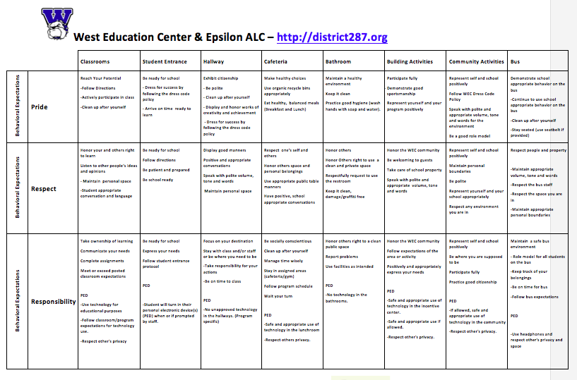
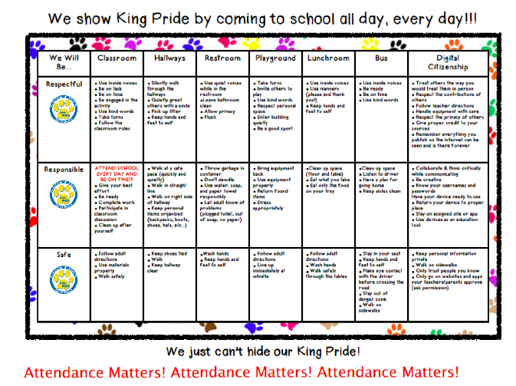
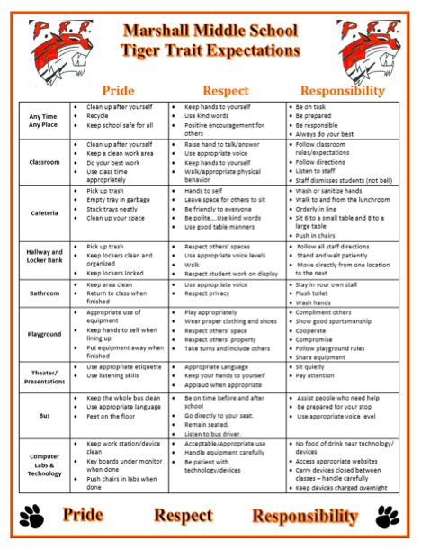

[Type text] [Type text] [Type text]

PBIS Team Workbook v1 7-2017
School: Date:

88
[Type text] [Type text] [Type text]

Page 88

PBIS Team Workbook v1 7-2017
School: Date:

Page 88 1A Overview Activities

PBIS Team Workbook v1 7-2017
School: Date:

Page 88 1B Team Activities
(TFI 1.1 & 1.2)

PBIS Team Workbook v1 7-2017
School: Date:

Page 88 1C Behavioral Expectations
(TFI 1.3)

PBIS Team Workbook v1 7-2017
School: Date:

Page 88 1C Behavioral Expectations
(TFI 1.3)

PBIS Team Workbook v1 7-2017
School: Date:

Page 89 2A Teaching Expectations
(TFI 1.4)

PBIS Team Workbook v1 7-2017
School: Date:

Page 89

2B Fidelity Data and Annual Evaluation
(TFI 1.14 & 1.15)

PBIS Team Workbook v1 7-2017
School: Date:

89

PBIS Team Workbook v1 7-2017
School: Date:

89
Tiered Fidelity Inventory (TFI)

PBIS Team Workbook v1 7-2017
School: Date:

89
Tiered Fidelity Inventory (TFI)
Action Plan

Appendix-TIPS Meeting Agenda

Appendix-TIPS Meeting Agenda

TIPS II (September 2015). Meeting Minutes Form

Appendix- Sample Matrix

Appendix- Sample Matrix

Appendix-Sample Matrix

Organization of Modules

My Profile

_______________________________________
_______________________________________

_______________________________________
_______________________________________
_______________________________________

_______________________________________
_______________________________________
_______________________________________
_______________________________________
_______________________________________
_______________________________________
_______________________________________

Corresponding Supports

_______________________________________
_______________________________________

_______________________________________
_______________________________________
_______________________________________

_______________________________________
_______________________________________
_______________________________________
_______________________________________
_______________________________________
_______________________________________
_______________________________________

Tier I
List Core practices provided to all students and intended to support most students

Tier III
List Individualized/Intensive practices provided to a few students for support

Tier II
List Strategic/Targeted practices provided to some students for support

Draft 3-10-04 Sugai
To calculate, divide # positives by # of negatives.
Setting or activity in which academic instruction or teacher/staff-directed activities are not available to engage students (e.g., cafeteria, playground, common areas, bus, hallways, parking lots, assemblies, sporting events).
What? When? How? By When?
Revised from Sugai & Colvin
To calculate, divide # positives by # of negatives.
What? When? How? By When?

