School Wide-Positive Behavioral Interventions and Supports (SWPBIS)

PBIS Team Training
Workbook

Center on Positive Behavioral Interventions and Supports
Minnesota Positive Behavioral Interventions and Supports
(updated July 2017)
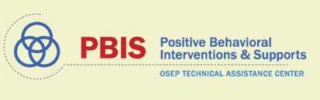  (www.pbis.org) | (www.pbisMN.org)
This document is supported in part by the OSEP Center on Positive Behavioral Interventions and Supports (http://pbis.org.) The Center is supported by a grant from the Office of Special Education Programs, US Department of Education (H326S130004). Opinions expressed herein are those of the authors and do not necessarily reflect the position of the US Department of Education, and such endorsements should not be inferred

Team Workbook

Take 2 minutes to determine roles within your groups for today’s training. The persons identified for these roles may be the same or different than the individuals filling these roles on your Tier 1 Team.

Team Roles | Name(s)
Coach/Facilitator  The Coach/Facilitator ensures that the group moves smoothly through the task at hand. This person seeks information and opinions, asks for facts and feelings from each team member, and summarizes main points of discussion. This role is very important because the facilitator leads the group through the tasks. | Coach/Facilitator
Recorder/Minute Taker  The recorder writes down the work of the group. This can involve writing words or sentences, drawing pictures, or simply taking notes of an activity. This role is very important because it is necessary to keep a record of the work done. | Recorder/Minute Taker
Time Keeper  This person is responsible for keeping up with the time. It is very important that the group is aware of how much time they have to complete the task as well as reminders on when the time is growing short. | Time Keeper
Reporter/Communicator  This person is responsible for reporting back the work of their small group to the presenter or to the larger group. This role is very important because this communication to the large group will be crucial in the learning process. | Reporter/Communicator
Data Analyst  This person should have ready access to available school data, including, but not limited to discipline information, etc. This role is important because data drives problem solving and decision-making. | Data Analyst

Appreciation is given to the following for their contributions to this Professional Learning
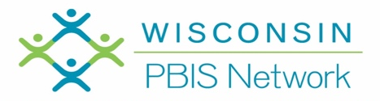
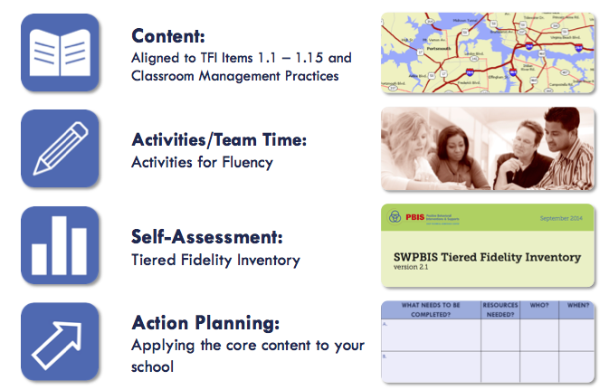

Organization of Modules

TIER I TRAINING: Overview 1A

Activity 1: How do you define and explain PBIS?

- Introduce yourself to your shoulder partner.
- First person explains PBIS in their words in 1 minute
- Second person reflect, and give feedback and/or additional details

Activity 2: My Personal Profile and Supports

- Use the blank triangle below to identify areas of your life where you are successful with Tier 1 supports, areas that need Tier 2 supports, and areas that need Tier 3 supports. Consider adding social, emotional, academic, physical, and/or professional examples.
My Profile

_______________________________________
_______________________________________

_______________________________________
_______________________________________
_______________________________________

_______________________________________
_______________________________________
_______________________________________
_______________________________________
_______________________________________
_______________________________________
_______________________________________

Corresponding Supports

_______________________________________
_______________________________________

_______________________________________
_______________________________________
_______________________________________

_______________________________________
_______________________________________
_______________________________________
_______________________________________
_______________________________________
_______________________________________
_______________________________________

- Next, identify an example of support for you receive for each area listed.

Activity 3: Rethinking Discipline
- Read the following information in the “Rethinking Discipline” chart. Record your thoughts.
- Share your thoughts with another person in your group.
- What did you hear from others that give you pause to rethink your understanding of discipline?
- Share the key ideas that may restructure your view of discipline with your team.

Rethinking Discipline

Academic & Social Problems: A Comparison of Approaches

Error Type | Approaches for Academic  Problems | Approaches for Social Problems
Infrequent | - Assume student is trying to make correct responses; error was accidental, a skill deficit.  - Provide assistance (teach, model, guide, check)  - Provide more practice and feedback; monitor progress.  - Assume student has learned skill and will perform correctly in the future. | - Assume student is choosing to be “bad;” error was deliberate, a performance deficit.  - Use consequences/punish.  - Practice not required.  - Assume student has “learned” lesson and will behave in the future.
Frequent | - Assume student has learned the wrong way or has inadvertently been taught the wrong way.  - Diagnose problem; identify misrule or determine more effective way to teach.  - Adjust teaching arrangements to accommodate learner needs. Provide practice and feedback.  - Assume student has learned skill and will perform correctly in the future. | - Assume the student is refusing to cooperate; student knows what is right, has been told to stop, and is being insubordinate.  - Provide more severe consequences; remove the student from normal context (office referral, detention, suspension, etc.)  - Maintain student removal from the normal context.  - Assume student has “learned” lesson and will behave in the future.

Activity 4: Creating a Vision (use chart paper and post-its if possible)
Guiding Question:
Do you have a vision that compels new ways of thinking and acting?
Working with your staff or team, discuss your vision of your school:
- Use post-it notes capture your ideas. Add your ideas to the chart paper.
- If you could create the school of your dreams, what would it LOOK like and SOUND like with a positive, proactive, and instructional approach to discipline?
- What are your intended OUTCOMES for your school?
- How will this align with your School Improvement Plan, your Mission & Vision Statements?
- Is this vision consistent with your 3-5 Positively Stated School-Wide Expectations?

Thinking about our Team Vision/Purpose
As a result of our efforts, our school will…
Look like …  What will we see? | Sound like …  What will we hear?
Achieve these outcomes …

TIER I TRAINING: TEAMS 1B
Team Composition and Team Operating Procedures

Activity 1: Initiative Inventory
Quick Audit/Resource Map of Current Practices within Three-Tiered Model of Support

Use a large sheet of chart paper to draw a large triangle and complete the following activity.
Step 1: Identify all programs/initiatives/common practices by tier
Tier I - How do you support all children? Core Curriculum - “everyone gets”
Tier II, III - How do you support students who need more support? How do you build on the foundation so that all Tier II, III activities are a natural extension of core curriculum?

Tier I
List Core practices provided to all students and intended to support most students

Tier III
List Individualized/Intensive practices provided to a few students for support

Tier II
List Strategic/Targeted practices provided to some students for support

Step 2: Consider the following questions:
Can you identify an outcome for each practice? Are these evidence-based practices?
How do you measure effectiveness? (Staff performance)
How do monitor progress? (Student impact)
How do you support teachers? (Staff supports)
How are they linked to School Improvement? (Integrated approach)

Directions: Identify any additional action steps needed. Do you need to enlist the other members of your team, and faculty to complete this quick audit of practices at your school?

Activity 2: Aligning Teaming Structures =Initiative Inventory
(Working Smarter, Not Harder)

Use the Initiative Inventory worksheet to complete the next two steps:
Step 1: Identify Current Teams (discipline, instruction, climate, school improvement, parent support, etc.) and Initiatives (Second Step, Character Counts, Spirit Committee, etc.)
Step 2: Complete the Working Smarter Table
Step 3: Based on your results, what committees or initiatives can you eliminate; combine; provide more support? How can you infuse PBIS into your current committees/teams?

Initiative/  Committee/ Team | Purpose and Strategic Goal Supported | Measurable Outcome(s) – Data Based | Target Group | Staff Involved | Overlap? Modify?  Eliminate?

Activity 3: Behavior Purpose Statement

Develop a brief statement of purpose relative to the development and support of the social and behavioral climate of the school. When developing the statement consider the following guidelines:
- Positively Stated
- 2-3 sentences in length
- Supportive of academic achievement
- Contextually/culturally appropriate (e.g., age, level, language)
- Comprehensive in scope (school-wide, ALL students, staff and settings)
- Agreement by >80% faculty and staff
- Communicated to stakeholders (e.g., families, community members, district administrators)
- Included in school publications (e.g., handbook, posters, newsletters)
- Reviewed at every team meeting

Activity 4: Effective Meetings: Team Composition
Identify your team members.
Step 1: Complete the following chart to ensure that your team includes a Tier I school-based coach, a school administrator, a family member, and individuals able to provide: behavioral expertise, coaching expertise, knowledge of student academic and behavioral patterns, knowledge about the operations of the school across grade levels; and student representation.

Step 2: Identify who will be the Data Entry person, the Data Analyst, the Facilitator, and Minute Taker for the TIPS process. Identify back-ups for each role.

Step 3: Identify the administrator and additional active team members.

Step 4: Determine dates to meet (at least monthly) and dates to present to the faculty (share data at least quarterly).

Name | Role | Back-Up | Email | Phone #
Day to meet: |  |  | Time:
Location: Dates to present to faculty:

Activity 5: Effective Meetings: Agenda and structure during team meetings

Step 1:Review the TIPS Meeting Agenda format in the appendix.
Step 2: Identify and discuss key sections of the agenda
  - Member Names
  - Agenda Items
  - Previous Precision Problem Statement
  - General Issues
  - New Precision Problem Statement
  - Evaluation of Meeting

Step 3: Plan for the format/content of your team meeting.

Activity 5: Working Agreements = Norms
Reflect on the professional behaviors that characterize efficient and effective meetings you have attended. What working agreements will support your team’s work and heighten your productivity?

TIER I TRAINING: TEAMS
Team Composition and Team Operating Procedures

Tiered Fidelity Inventory: Tier I
Features
1.1 Team Composition:
Tier I team includes a Tier I systems coordinator, a school administrator, a family member, and individuals able to provide (a) applied behavioral expertise, (b) coaching expertise, (c) knowledge of student academic and behavior patterns, (d) knowledge about the operations of the school across grade levels and programs, and for high schools, (e) student representation.
1.2 Team Operating Procedures:
Tier I team meets at least monthly and has (a) regular meeting format/agenda, (b) minutes, (c) defined meeting roles, and (d) a current action plan
TFI | Action Item  (Not In Place; Partially; Fully In Place ->) | NI | PI | FI
1.1 | Team has administrative support and represents school community
1.1 | Back-up members are identified for all team functions (coach, data-analyst, recorder, data-entry, etc.)
1.2 | Team has established a clear mission/purpose and current action plan.
1.2 | Team runs efficient and effective regular meetings (at least monthly) with agenda and meeting minutes
1.2 | School administrator is an active participant in 90% of meetings, protects meeting time, disseminates information during grade level/department meetings, faculty meetings, and parent/family meetings.
1.2 | Working Smarter Teaming Alignment document is completed

TIER I TRAINING: IMPLEMENTATION: Behavioral Expectations 1C

Activity 1: Build Expectations
If your school system does not have school-wide expectations, proceed to developing expectations for your school, consider the following activity:
- Each team member gets three sticky notes to record one expectation per sticky note.
- Enter expectations considered in the box below.
- Reach consensus as a team on three to five
- Can you give your school expectations an easy to remember and catchy name?

Expectations Considered | Ideas for the Name of School Expectations

Activity 2: Creating a Matrix
Enter your agreed upon expectations on the matrix below

Expectations Name: _____________________ | Expectations | Locations
 | Conditions for Learning/Teacher Supports

Activity 3: Locations
Guiding Question: What does your map look like?
- Draw a diagram/map of your school in this box, on chart paper, or use a copy of your school map.
- Each person identifies 3 top problem locations
- On the bottom half, identify where, what, who, when, and why.

Map of our school

Where? | What? | When? | Who? | Why are they happening?

Activity 4: Teaching Matrix
Using the information from Activity 3, identify the locations of your school and enter them onto the matrix above.

Activity 5: Behaviors
Using the information from “where”, “what”, “when”, “who” and “why”, begin to identify possible rules for the locations in your school. What problems were identified? What do you want to see instead?

When defining specific behaviors/rules they should be:
- Observable behaviors – that we can see
- Measureable – we could actually count the occurrence of the behavior
- Positively stated – what to do to be successful
- Understandable – student-friendly language
- Always applicable – able to accomplish in all settings in the school

Activity 6: Finalizing your School-wide Matrix
- Consider adding supports for teachers (i.e. conditions for learning)
- Consider adding pro-social skills
- Prepare to share one completed location with the group (e.g., what does Respect look like in the cafeteria?)

Activity 7: Classroom Rules
Define classroom rules aligning with School-wide expectations. Complete one square and prepare to share.

Setting ➔ | Classroom Rules | Classroom Routines
School-wide Expectation ⬇

Activity 8: Classroom Procedures and Routines
Identify at least one routine in the classroom. Define the steps and align the steps to the school-wide expectations. Add the routine to the Classroom Matrix in Activity 7. Prepare to share.

TIER I TRAINING: IMPLEMENTATION
Behavioral Expectations

Tiered Fidelity Inventory: Tier I Features
1.3 Behavioral Expectations:
School has five or fewer positively stated behavioral expectations and examples by setting/location for student and staff behaviors (e.g., school teaching matrix) defined and in place.

TFI | Action Item  (Not In Place; Partially; Fully In Place ->) | NI | PI | FI
1.3 | Staff are involved in development of expectations and rules
1.3 | 3-5 positively stated school-wide expectations are posted around school
1.3 | Teaching matrix is developed to identify rules linked to expectations in various areas in the school
1.3 | Rules are posted in specific settings/locations
1.3 | Expectations apply to both students and staff
1.8 | Classroom rules are defined, aligned to school-wide expectations, and are posted in classrooms.
1.8 | Classroom routines and procedures are explicitly identified for activities where problems often occur (e.g. entering class, asking questions, sharpening pencil, using restroom, dismissal)

TIER I TRAINING: IMPLEMENTATION - Teaching Expectations 2A
Activity 1: Develop Lesson Plans
- Choose a rule/routine from the school-wide or classroom-wide matrix.
- Work with your shoulder partner or team to complete the behavior lesson plan template at your table.
- Be ready to describe your lesson to the group and possibly role-play the example and non-example.

Expectation:
Location:
Establish/Define Behavior/Procedure:
Introduce the behavior and why it is important. Be sure to list when the behavior is expected:
1.

2.

3.
TEACH

Teacher demonstrates or models the behavior. Discuss non-examples and examples.
1.

2.

3.
PRACTICE

Give students opportunities to role-play the behaviors across all relevant settings.
1.

2.

3.
MONITOR AND REINFORCE
- Pre-Correct/Remind: Anticipate and give students a reminder to perform behaviors
- Supervise: Move, scan and interact with students.
- Feedback: Observe student performance and give positive, specific feedback to students.
- Reteach: Practice throughout the day and school year.
Activity 2: Creating a Plan for Teaching Desired Behaviors
Once the behavior lesson plans are created it is important to take time to decide how the lessons will be taught, not only at the beginning of the year, but throughout the year.
- Create a draft plan to teach expectations. Encourage input from all staff members to complete the Teaching Expectations Plan.

What will be done? | How will it be done? | When will it be done?
Use “best instructional practices” to teach social skills?

Introduce the expectations

Will you embed into subject area curriculum?
Create/Post the Matrix

Establish a signal for obtaining class attention & transitions

Model what the expectations look like
Will faculty and staff model appropriate behavior?
Practice with students
Will you teach directly in settings? (i.e. bus expectations taught on bus)
Provide specific feedback

Acknowledge students who demonstrate the expected behavior
Pre-correct and Review often

How will lessons be taught throughout the school year?
How will lessons be taught to new students and new faculty/staff?

TIER I TRAINING: IMPLEMENTATION
Teaching Expectations

Tiered Fidelity Inventory: Tier I Features
1.4 Teaching Expectations: Expected academic and social behaviors are taught directly to all students in classrooms and across other campus settings/locations.

TFI | Action Item  (Not In Place; Partially; Fully In Place ->) | NI | PI | FI
1.4 | A behavioral curriculum includes teaching expectations and rules for each location in the school
1.4 | Lesson include examples and non-examples (student/staff practice examples only)
1.4 | Lessons use a variety of teaching strategies
1.4 | Lessons are embedded into subject area curriculum
1.4 | Lessons will be taught and re-taught throughout the school year
1.4 | Staff and students are involved in development & delivery of behavioral curriculum
1.4 | Strategies to share key features of PBIS program with families/community are developed and implemented
1.4 | Identify dates on the school’s professional development calendar when the expectations will be formally taught to all students
1.7 | Identify dates on the school’s professional development calendar when the plans for teaching expectations will be shared with staff
1.8 | Expected classroom behaviors and routines are taught

TIER I TRAINING: EVALUATION 2B
Fidelity Data and Annual Evaluation

Activity 1: Fidelity Data and Annual Evaluation
Guiding Questions:
- What are the different types of data your team will be using to make decisions about PBIS implementation?
- What kind of “statement” do you need to be able to make regarding your data? What are the pieces of that statement?
- What is your elevator speech for when colleagues ask you about “all this data collection”?

TIER I TRAINING: EVALUATION
Fidelity Data and Annual Evaluation

Tiered Fidelity Inventory: Tier I Features
1.14 Fidelity Data:
Tier I team reviews and uses PBIS fidelity (e.g., SET, BoQ, SAS, Tiered Fidelity
Inventory) data at least annually.
1.15 Annual Evaluation:
Tier I team documents fidelity and effectiveness (including on academic outcomes) of Tier I practices at least annually (including year-by-year comparisons) that are shared with stakeholders (staff, families, community, district) in a usable format.

TFI | Action Item  (Not In Place; Partially; Fully In Place ->) | NI | PI | FI
1.14 | Students and staff are surveyed
1.14 | Students and staff can identify expectations and rules
1.14 | Staff use referral process (including which behaviors are office managed vs. teacher managed) and forms appropriately
1.14 | Staff use acknowledgment system appropriately
1.14 | Outcomes (behavior problems, attendance, morale) are documented and used to evaluate plan
1.14 | Staff, student and family surveys are developed with timeline for completion
1.14 | Intended student outcomes are identified and monitored
1.15 | Fidelity tools are identified, administered and used to inform action planning

Tiered Fidelity Inventory (TFI)
Tiered Fidelity Inventory – Tier 1
Tier 1 Subscale and Feature | Definition |  | Possible Data Sources | Criteria  0=Not implemented; 1=Partially implemented; 2=Fully implemented |  | Score 0, 1, 2
TEAMS
1.1 Team Composition | Tier I team includes a Tier I systems coordinator, a school administrator, a family member, and individuals able to provide (a) applied behavioral expertise, (b) coaching expertise, (c) knowledge of student academic and behavior patterns, (d) knowledge about the operations of the school across grade levels and programs, and for high schools, (e) student representation. |  | - School organizational chart  - Tier I team meeting minutes | 0 = Tier I team does not exist or does not include coordinator, school administrator, or individuals with applied behavioral expertise  1 = Tier I team exists, but does not include all identified roles or attendance of these members is below 80%  2 = Tier I team exists with coordinator, administrator, and all identified roles represented, AND attendance
1.2 Team Operating Procedures | Tier I team meets at least monthly and has (a) regular meeting format/agenda,  (b) minutes, (c) defined meeting roles, and (d) a current action plan. |  | - Tier I team meeting agendas and minutes  - Tier I meeting roles descriptions  - Tier I action plan | 0 = Tier I team does not use regular meeting format/ agenda, minutes, defined roles, or a current action plan  1= Tier I team has at least 2 but not all 4 features  2 = Tier I team meets at least monthly and uses regular meeting format/agenda, minutes, defined roles, AND has a current action plan
IMPLEMENTATION
1.3 Behavioral Expectations | School has five or fewer positively stated behavioral expectations and examples by setting/location for student and staff behaviors (i.e., school teaching matrix) defined and in place. |  | - TFI Walkthrough Tool  - Staff handbook  - Student handbook | 0 = Behavioral expectations have not been identified, are not all positive, or are more than 5 in number  1 = Behavioral expectations identified but may not include a matrix or be posted  2 = Five or fewer behavioral expectations exist that are positive, posted, and identified for specific settings (i.e., matrix) AND at least 90% of staff can list at least 67% of the expectations
1.4 Teaching Expectations | Expected academic and social behaviors are taught directly to all students in classrooms and across other campus settings/locations. |  | - TFI Walkthrough Tool  - Professional development calendar  - Lesson plans  - Informal walkthroughs | 0 = Expected behaviors are not taught  1 = Expected behaviors are taught informally or inconsistently  2 = Formal system with written schedules is used to teach expected behaviors directly to students across classroom and campus settings AND at least 70% of students can list at least 67% of the expectations
1.5 Problem Behavior Definitions | School has clear definitions for behaviors that interfere with academic and social success and a clear policy/ procedure (e.g., flowchart) for addressing office-managed versus staff-managed problems. |  | - Staff handbook  - Student handbook  - School policy  - Discipline flowchart | 0 = No clear definitions exist, and procedures to manage problems are not clearly documented  1 = Definitions and procedures exist but are not clear and/or not organized by staff- versus office-managed problems  2 = Definitions and procedures for managing problems are clearly defined, documented, trained, and share with families
1.6 Discipline Policies | School policies and procedures describe and emphasize proactive, instructive, and/ or restorative approaches to student behavior that are implemented consistently. |  | - Discipline policy  - Student handbook  - Code of conduct  - Informal administrator interview | 0 = Documents contain only reactive and punitive consequences  1 = Documentation includes and emphasizes proactive approaches  2 = Documentation includes and emphasizes proactive approaches AND administrator reports consistent use
1.7 Professional Development | A written process is used for orienting all faculty/staff on 4 core Tier I SWPBIS practices: (a) teaching school-wide expectations, (b) acknowledging appropriate behavior, (c) correcting errors, and (d) requesting assistance. |  | - Professional development calendar  - Staff handbook | 0 = No process for teaching staff is in place  1 = Process is informal/unwritten, not part of professional development calendar, and/or does not include all staff or all 4 core Tier I practices  2 = Formal process for teaching all staff all aspects of Tier I system, including all 4 core Tier I practices
1.8 Classroom Procedures | Tier I features (school-wide expectations, routines, acknowledgements, in-class continuum of consequences) are implemented within classrooms and consistent with school-wide systems. |  | - Staff handbook  - Informal walkthroughs  - Progress monitoring  - Individual classroom data | 0 = Classrooms are not implementing Tier I  1 = Classrooms are informally implementing Tier I but no formal system exists  2 = Classrooms are formally implementing all core Tier I features, consistent with school-wide expectations
1.9 Feedback and Acknowledge-ment | A formal system (i.e., written set of procedures for specific behavior feedback that is [a] linked to school-wide expectations and [b] used across settings and within classrooms) is in place and used by at least 90% of a sample of staff and received by at least 50% of a sample of students. |  | - TFI Walkthrough Tool  - Staff Handbook | 0 = No formal system for acknowledging students  1 = Formal system is in place and is used by at least 90% of staff OR received by at least 50% of students  2 = Formal system for acknowledging student behavior is used by at least 90% of staff AND received by at least 50% of students
1.10 Faculty Involvement | Faculty are shown school- wide data regularly and provide input on universal foundations (e.g., expectations, acknowledgements, definitions, consequences) at least every 12 months. |  | - PBIS Self-Assessment Survey  - Informal surveys  - Staff meeting minutes  - Team meeting minutes | 0 = Faculty are not shown data at least yearly and do not provide input  1 = Faculty have been shown data more than yearly OR have provided feedback on Tier I foundations within the past  12 months but not both  2 = Faculty are shown data at least 4 times per year AND have provided feedback on Tier I practices within the past 12 months
1.11 Student/ Family/ Community Involvement | Stakeholders (students, families, and community members) provide input on universal foundations (e.g., expectations, consequences, acknowledgements) at  least every 12 months. |  | - Surveys  - Voting results from parent/ family meeting  - Team meeting minutes | 0 = No documentation (or no opportunities) for stakeholder feedback on Tier I foundations  1 = Documentation of input on Tier I foundations, but not within the past 12 months or input but not from all types of stakeholders  2 = Documentation exists that students, families, and community members have provided feedback on Tier I practices within the past 12 months
EVALUATION
1.12 Discipline Data | Tier I team has instantaneous access to graphed reports summarizing discipline data organized by the frequency of problem behavior events by behavior, location, time of day, and by individual student. |  | - School policy  - Team meeting minutes  - Student outcome data | 0 = No centralized data system with ongoing decision making exists  1 = Data system exists but does not allow instantaneous access to full set of graphed reports  2 = Discipline data system exists that allows instantaneous access to graphs of frequency of problem behavior events by behavior, location, time of day, and student
1.13 Data-based Decision Making | Tier I team reviews and uses discipline data and academic outcome data (e.g., Curriculum-Based Measures, state tests) at least monthly for decision-making. |  | - Data decision rules  - Staff professional development calendar  - Staff handbook  - Team meeting minutes | 0 = No process/protocol exists, or data are reviewed but not used  1 = Data reviewed and used for decision-making, but less than monthly  2 = Team reviews discipline data and uses data for decision-making at least monthly. If data indicate an academic or behavior problem, an action plan is developed to enhance or modify Tier I supports
1.14 Fidelity Data | Tier I team reviews and uses SWPBIS fidelity (e.g., SET, BoQ, TIC, SAS, Tiered Fidelity Inventory) data at least annually. |  | - School policy  - Staff handbook  - School newsletters  - School website | 0 = No Tier I SWPBIS fidelity data collected  1 = Tier I fidelity collected informally and/or less often than annually  2 = Tier I fidelity data collected and used for decision making annually
1.15 Annual Evaluation | Tier I team documents fidelity and effectiveness (including on academic outcomes) of Tier I practices at least annually (including year- by-year comparisons) that are shared with stakeholders (staff, families, community, district) in a usable format. |  | - Staff, student, and family surveys  - Tier I handbook  - Fidelity tools  - School policy  - Student outcomes  - District reports  - School newsletters | 0 = No evaluation takes place, or evaluation occurs without data  1 = Evaluation conducted, but not annually, or outcomes are not used to shape the Tier I process and/ or not shared with stakeholders  2 = Evaluation conducted at least annually, and outcomes (including academics) shared with stakeholders, with clear alterations in process based on evaluation
Total Score | Items/Points | Points Award/Points Possible |  |  | Percentage of PBIS Implementation
Tier 1 | 1-15 / 30 points | ____________ / 30

PBIS Action Plan:

Directions:
- Complete the following action plan to document steps toward implementation of PBIS.
- See Action Items at the end of each module in the workbook to identify action steps for inclusion in plan.
- Add additional action steps as identified by team.

Subscale and  Tier 1 Features | Score from TFI:  0, 1, 2 | Action Steps: |  | Who? |  | When?
TEAMS
- Team Composition  DAY 1 |  | 1.  PD Plan:
- Team Operating Procedures  DAY 1 |  | 1.  PD Plan:
IMPLEMENTATION
- Behavioral Expectations  DAY 2 |  | 1.  PD Plan:
1.4 Teaching Expectations |  | 1.  PD Plan:
1.5 Problem Behavior Definitions |  | 1.  PD Plan:
1.6 Discipline Policies |  | 1.  PD Plan:
1.7 Professional Development |  | 1.
1.8 Classroom Procedures  DAY 2 and DAY 5 |  | 1.  PD Plan:
1.9 Feedback and Acknowledgement |  | 1.  PD Plan:
1.10 Faculty Involvement |  | 1.  PD Plan:
1.11 Student/Family/ Community Involvement |  | 1.  PD Plan:
EVALUATION
1.12 Discipline Data |  | 1.  PD Plan:
1.13 Data-based Decision Making |  | 1.  PD Plan:
1.14 Fidelity Data |  | 1.  PD Plan:
1.15 Annual Evaluation |  | 1.  PD Plan:
OTHER ACTION STEPS: |  |  | Who? |  | When?

[INSERT LOGO HERE]
TIPS Meeting Minutes Guide |  |  |  |  |  | School:
 |  | Date | Time (begin and end) | Location | Facilitator |  | Minute Taker |  | Data Analyst
 | Today’s Meeting
 | Next Meeting

Team Members & Attendance (Place “X” to left of name if present)

Today’s Agenda Items: |  |  |  | Agenda Items for Next Meeting
1. |  | 4. |  | 1.
2. |  | 5. |  | 2.
3. |  | 6. |  | 3.

Systems Overview
Overall Status Tier/Content Area | Measure Used | Data Collection Schedule | Current Level/Rate
Problem Solving Process

Date of Initial Meeting: |  |  |  |  | Date(s) of Review Meetings
Brief Problem Description (e.g., student name, group identifier, brief item description):
Precise Problem ➔  Statement  What? When? Where? Who? Why? How Often? | Goal and ➔  Timeline  What? By When? | Solution ➔  Actions  By Who? By When? | Identify Fidelity ➔  and Outcome Data  What? When? Who? | I  M  P  L  E  M  E  N  T  S  O  L  U  T  I  O  N  S | Did it work?  (Review current levels and compare to goal)  ⬇
 |  |  | What fidelity data will we collect?  What? When? Who? |  | Fidelity Data:  Level of Implementation  Not started  Partial implementation  Implemented with fidelity  Stopped  Notes: | Outcome Data (Current Levels):  Comparison to Goal  Worse  No Change  Improved but not to goal  Goal met  Notes:
What outcome data will we collect?
What? When? Who?
Current Levels: |  |  |  |  | Next Steps
Continue current plan
Modify plan
Discontinue plan
Other
Notes:

Date of Initial Meeting: |  |  |  |  | Date(s) of Review Meetings
Brief Problem Description (e.g., student name, group identifier, brief item description)
Precise Problem ➔  Statement  What? When? Where? Who? Why? How Often? | Goal and ➔  Timeline  What? By When? | Solution ➔  Actions  By Who? By When? | Identify Fidelity ➔  and Outcome Data  What? When? Who? | I  M  P  L  E  M  E  N  T  S  O  L  U  T  I  O  N  S | Did it work?  (Review current levels and compare to goal)  ⬇
 |  |  | What fidelity data will we collect?  What? When? Who? |  | Fidelity Data:  Level of Implementation  Not started  Partial implementation  Implemented with fidelity  Stopped  Notes: | Outcome Data (Current Levels):  Comparison to Goal  Worse  No Change  Improved but not to goal  Goal met  Notes:
What outcome data will we collect?
What? When? Who?
Current Levels: |  |  |  |  | Next Steps
Continue current plan
Modify plan
Discontinue plan
Other
Notes:

Notes:

[Paste new problem table(s) as needed]

Organizational/Housekeeping Task List
Item | Discussion | Decisions and Tasks | Who? | By When?

Evaluation of Team Meeting (Mark your ratings with an “X”) | Our Rating
 | Yes | So-So | No
1. Was today’s meeting a good use of our time?
2. In general, did we do a good job of tracking whether we’re completing the tasks we agreed on at previous meetings?
3. In general, have we done a good job of actually completing the tasks we agreed on at previous meetings?
4. In general, are the completed tasks having the desired effects on student behavior?

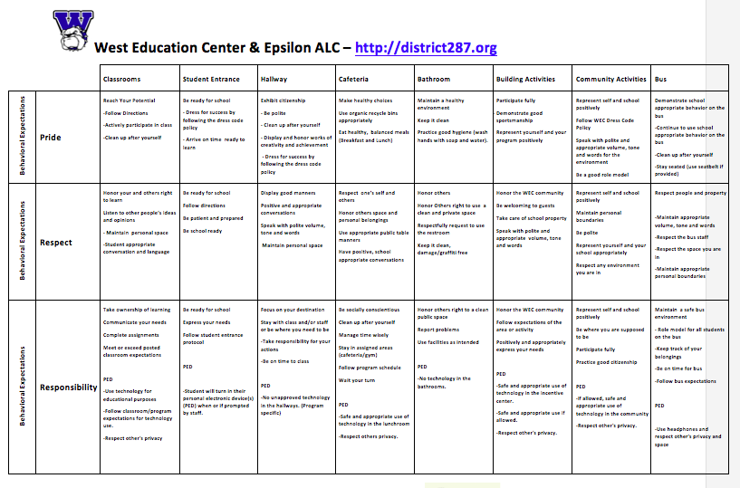
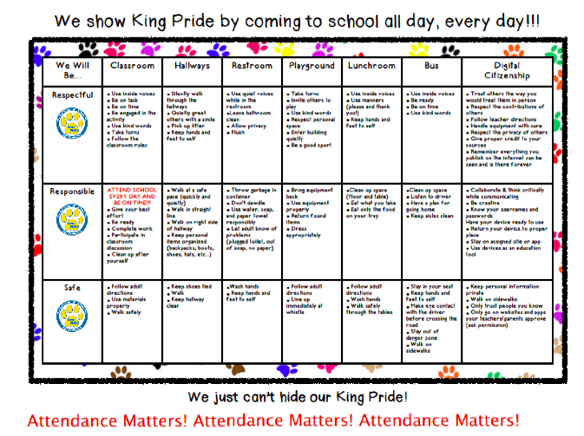
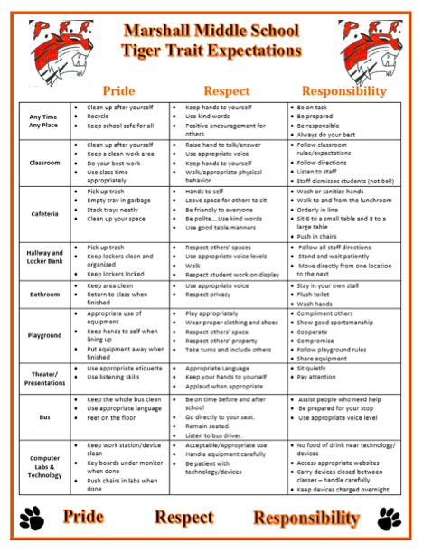

[Type text] [Type text] [Type text]

PBIS Team Workbook v1 7-2017
School: Date:

[Type text] [Type text] [Type text]

Page 2

PBIS Team Workbook v1 7-2017
School: Date:

Page 3 1A Overview Activities

PBIS Team Workbook v1 7-2017
School: Date:

Page 12 1B Team Activities
(TFI 1.1 & 1.2)

PBIS Team Workbook v1 7-2017
School: Date:

Page 13 1C Behavioral Expectations
(TFI 1.3)

PBIS Team Workbook v1 7-2017
School: Date:

Page 20 1C Behavioral Expectations
(TFI 1.3)

PBIS Team Workbook v1 7-2017
School: Date:

Page 23 2A Teaching Expectations
(TFI 1.4)

PBIS Team Workbook v1 7-2017
School: Date:

Page 25

2B Fidelity Data and Annual Evaluation
(TFI 1.14 & 1.15)

PBIS Team Workbook v1 7-2017
School: Date:

26

PBIS Team Workbook v1 7-2017
School: Date:

28
Tiered Fidelity Inventory (TFI)

PBIS Team Workbook v1 7-2017
School: Date:

31
Tiered Fidelity Inventory (TFI)
Action Plan

Appendix-TIPS Meeting Agenda

Appendix-TIPS Meeting Agenda

TIPS II (September 2015). Meeting Minutes Form

Appendix- Sample Matrix

Appendix- Sample Matrix

Appendix-Sample Matrix

Organization of Modules

My Profile

_______________________________________
_______________________________________

_______________________________________
_______________________________________
_______________________________________

_______________________________________
_______________________________________
_______________________________________
_______________________________________
_______________________________________
_______________________________________
_______________________________________

Corresponding Supports

_______________________________________
_______________________________________

_______________________________________
_______________________________________
_______________________________________

_______________________________________
_______________________________________
_______________________________________
_______________________________________
_______________________________________
_______________________________________
_______________________________________

Tier I
List Core practices provided to all students and intended to support most students

Tier III
List Individualized/Intensive practices provided to a few students for support

Tier II
List Strategic/Targeted practices provided to some students for support

