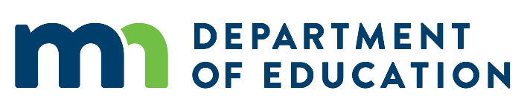

# 2018-19 Minnesota PBIS Ambassador School Program

# Application

## School Information

District:

Name of the school:

Level of students served:

Regional Implementation Project for the school:

Name of the person submitting the application:

Telephone number:

Email address:

In which Cohort was the school trained?

Has the school been selected as a Sustaining Exemplar School?

If so, when?

Please list the members of the school’s PBIS team, including their positions in the school and roles on the team; highlight those who are most likely to deliver the presentations:

## PBIS Implementation Information

Please provide PBIS Tier 1 fidelity information for the school from at least the last 12 months and up to 3 years if possible. For each fidelity assessment, specify: the instrument used, date administered, and results.

What data or progress tracking system does the school use for tracking student behavior?

Provide an example of recent student data that the school has acted upon, describing the issue identified and the solution that was initiated.

Provide any additional information about the school’s efforts and use of PBIS that will strengthen its application.

## Annual Plan Agreement Information

Does the school have any Annual Plan Agreements with MDE in effect for FY19? If so, for how much funding?

## Application Submission

Applications, prepared as Word documents, are to be sent to [MDE.PBIS@state.mn.us](mailto:MDE.PBIS@state.mn.us) **by 4:00pm on February 4, 2019.**