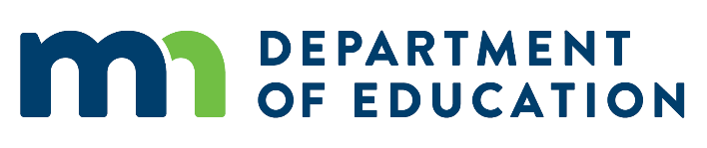
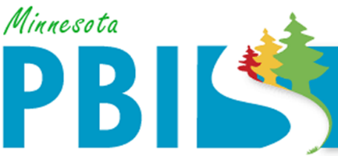

2015-2016 Minnesota PBIS District Recognition
To be identified for District PBIS Recognition, districts must demonstrate capacity for coordination, training, coaching and evaluation to support schools in their district to implement SW-PBIS. There were five districts that applied and met criteria.
Saint Paul
There are 66 schools in the district of which 30 went through cohort training with the state and 24 received training through a local model. 23 schools measured fidelity in the past 12 months and 87% of those met fidelity of implementation.

Caledonia
There are 4 schools in the district of which 2 went through cohort training. Two schools measured fidelity in the previous 12 months and 100% of those schools met fidelity of implementation.

TEAM Academy
There is one school in the district which has been through training, has measured fidelity in the past 12 months and is implementing with fidelity.

Mankato
There are 17 schools in the district of which 16 have been through a local model of training. 16 schools have measured fidelity in the past year and 100% of those schools met fidelity of implementation.

Pine Island
There are four schools in the district of which 2 have been through PBIS training. Two schools have measured fidelity in the past 12 months and both were implementing with 100% fidelity.

