CALL FOR PRESENTATIONS for PBIS Institute
POSTER SESSION
Please return this form by April 15, 2017

Annual Minnesota PBIS Institute:
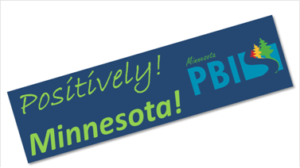

June 20-21, 2017
Minnesota Department of Education - Roseville, MN

The Minnesota School-Wide Positive Behavioral Interventions and Supports (PBIS) Team is pleased to announce:

The Annual PBIS Institute is seeking Poster Presentation proposals from administrators, educators, institutions of higher education, parent/advocacy organizations and related service professionals sharing information on effective strategies and practice in the field of School-Wide PBIS. Please note that if you are submitting more than one presentation a separate form must be completed for each.

- POSTER PRESENTATIONS: Posters are visual presentations for viewing by conference participants. Poster presentations must provide a description of the innovative practice and how it has impacted outcomes where they have been implemented. Each presenter will be provided space at a table for display. Deadline for poster presentations is April 15, 2017.

Click in the GREY shaded box to enter text.
Poster Session Title:

Poster Session Description: Maximum of 50 words -Approximately 2-3 typed lines. Write this as you would like it to be printed on the conference program describing your poster.

Primary Contact Information for Poster Presentation Submission: .

Primary Poster Session Contact: (Click in the GREY shaded boxes to enter text.)
Name Email:
School / agency:
Address:
City/State/Zip:
Day Phone:

Equipment Provided: Exhibit space for your poster will be provided.

Biography Information:

Contributor 1 Name and Title

Contributor 2 Name and Title

Contributor 3 Name and Title

Contributor 4 Name and Title:

The Conference Planning group will review all the submissions. All those submitting poster session proposals will be notified by email regarding the status of their proposal by May 11, 2016.

This completed form must be submitted by April 15, 2017 to: MDE.PBIS@state.mn.us with the subject of Poster Session Submission.

Any questions regarding this proposal or submission should also be submitted to MDE.PBIS@state.mn.us with the subject line 2017 PBIS Institute Question.

