How to Give the Self-Assessment Survey to Staff

Your school PBIS Assessment Coordinator must first open the SAS window
in PBIS Assessment before staff can take the survey.

- Communicate with staff that they will be getting a link to a survey regarding your school’s “Tiger Pride” or “Eagles Soar” program. Avoiding using PBIS as this term can be confusing.
- Stress that this survey is for ALL school staff.
- Let them know it is anonymous, and will provide valuable information for your school’s team to action plan around.
- Provide a glimpse of the survey.

Tell staff:
- They will be receiving a link to the survey and taking it via technology
- Survey is completed independently
- Takes 10 -20 minutes
- Ratings should be on individual experiences in the school
- They can skip questions not applicable to their role by choosing N/A
- Questions are twofold:
  - First determine the current status of a feature (In place, Partially in Place, Not in Place)
  - Then select priority for improvement. (High, Medium, Low)
Current Status |  |  | Feature | Priority for Improvement
In Place | Partial in  Place | Not in Place | School-wide is defined as involving all students, all staff, & all settings. | High | Med | Low
 |  |  | 1. A small number (e.g. 3-5) of positively & clearly stated student expectations or rules are defined.

For Example: In the above question if the respondent chooses “Partial in Place,” then what do they feel is the level of priority in getting this done- High, Medium or Low? If they chose “In Place” then they don’t need to choose a priority level
Where is the link for the survey found?
(A team member with access to PBIS Assessment (found in PBIS Apps) can access the link.)
1. Login to pbisapps.org
2. Choose PBIS Assessment
3. Under Open Surveys Window find the Self-Assessment Survey (SAS).
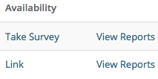
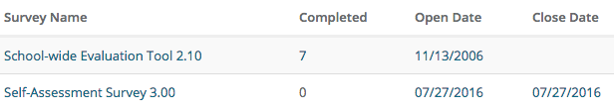

KEY:
Completed= how many people have completed the survey
View Reports= click here to view survey results (once the window has closed this line will move to the Closed Surveys Window box.)
Open Date = First day respondents can begin taking survey
Close Date = Last day respondents can take survey. This date can be edited by simply clicking on it
5. Click “Link” and this box will open:
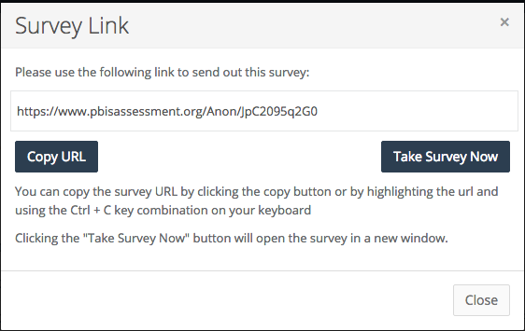

The Take Survey Now button can only be used by the person who is logged into PBIS Assessment system.

5. Copy and paste the link to share with staff via email or some other method.

Suggestions:
- Have staff bring devices to a staff meeting to take the survey
- Offer an incentive if x amount of staff take survey
- Find a time for cooks, custodians, secretaries and paras to take survey beyond prep and break times.
- After the data is analyzed an action plan is made share with staff so they see how their input is used.

Other Things You Can Tell Staff Prior to Taking SAS:
- When you see the word reward think of how we positively acknowledge students which does not have to be tangible (if you have developed any specific “terms” for rewards name them)
- When a team is mentioned it is the PBIS team that was trained (give names if desired)
- Reporting and collecting data is one job of the PBIS team
- The SAS and other measures assist teams/schools to write/complete action plans
- Booster trainings are re-teaching expectations, pep assemblies (name anything that you have in place or are developing to continue teaching the 3-5 school-wide expectations)
- Give them the answer for question 18 on SW settings
- For the “individual student system” tell them the name of the group(s) that address supports for chronic behavior, Problem Solving Team, child study, Tier II team, etc.
- Local resources may be district or (name any agencies that work with your students)

