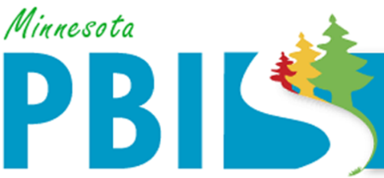

2018-2019 Minnesota PBIS District Recognition
In addition to individual school recognition, districts that are coordinating and supporting their PBIS schools are invited to apply for district recognition. To be identified for District PBIS Recognition, districts must demonstrate capacity for coordination, training, coaching and evaluation to support schools in their district to implement SW-PBIS.
There are two levels of recognition at the district level. The first is to highlight districts that are in progress towards sustaining implementation and have multiple schools measuring fidelity annually. The second is to highlight districts that have demonstrated exemplar district capacity with over 60% of schools implementing SW-PBIS with fidelity as measured annually.
Four (4) districts are being recognized for Sustaining Exemplar District capacity:
- Eastern Carver County Schools has fifteen (15) schools in the district. All fifteen (15) schools have been trained in PBIS. Fifteen (15) schools have measured fidelity in the past year and all of them are implementing SW-PBIS at Tier 1 with fidelity.
- St. Cloud Area School District 742 has sixteen (16) schools in the district. All sixteen (16) schools have been trained in PBIS. Thirteen (13) schools have measured fidelity in the past year and twelve (12) of those are implementing SW-PBIS at Tier 1 with fidelity.
- Osseo Area Schools has thirty (30) schools in the district. Fourteen (14) schools have been trained in PBIS through the state cohort model and an additional fifteen (15) have been trained internally. Twenty-five (25) schools have measured fidelity in the past year and eighteen (18) of those are implementing SW-PBIS at Tier 1 with fidelity.
- St. Paul Public Schools has sixty-three (63) schools in the district. Thirty (30) schools have been trained in PBIS through the state cohort model and an additional thirty-one (31) have been trained internally. Sixty (60) schools measured fidelity in the past year and 49 are implementing SW-PBIS at Tier 1 with fidelity.
Two (2) districts are being recognized for progressing towards sustaining implementation
- Cambridge-Isanti Schools has ten (10) schools in the district. All ten (10) schools have been trained in PBIS and have measured fidelity in the past year. Two (2) schools are implementing SW-PBIS at Tier 1 with fidelity.
- Burnsville Public Schools has fifteen (15) schools in the district. All fifteen (15) schools have been trained in PBIS. Fourteen (14) schools have measured fidelity in the past year and eight (8) of those are implementing SW-PBIS at Tier I with fidelity.

